Правила землепользования и застройки
муниципального образования
Токсовское городское поселение
Всеволожского муниципального района
ленинградской области

Приложение
Сведения о границах территориальных зон

Санкт-Петербург – Токсово
2018

Токсовское городское поселение

Графическое описание местоположения границ территориальных зон
ОД-1. Зона делового, общественного и коммерческого назначения
ИТ-1. Зона инженерной инфраструктуры

СХ-1. Зона сельскохозяйственного производства

ОТ-1. Зона особо охраняемых территорий

ИТ-2. Зона транспортной инфраструктуры

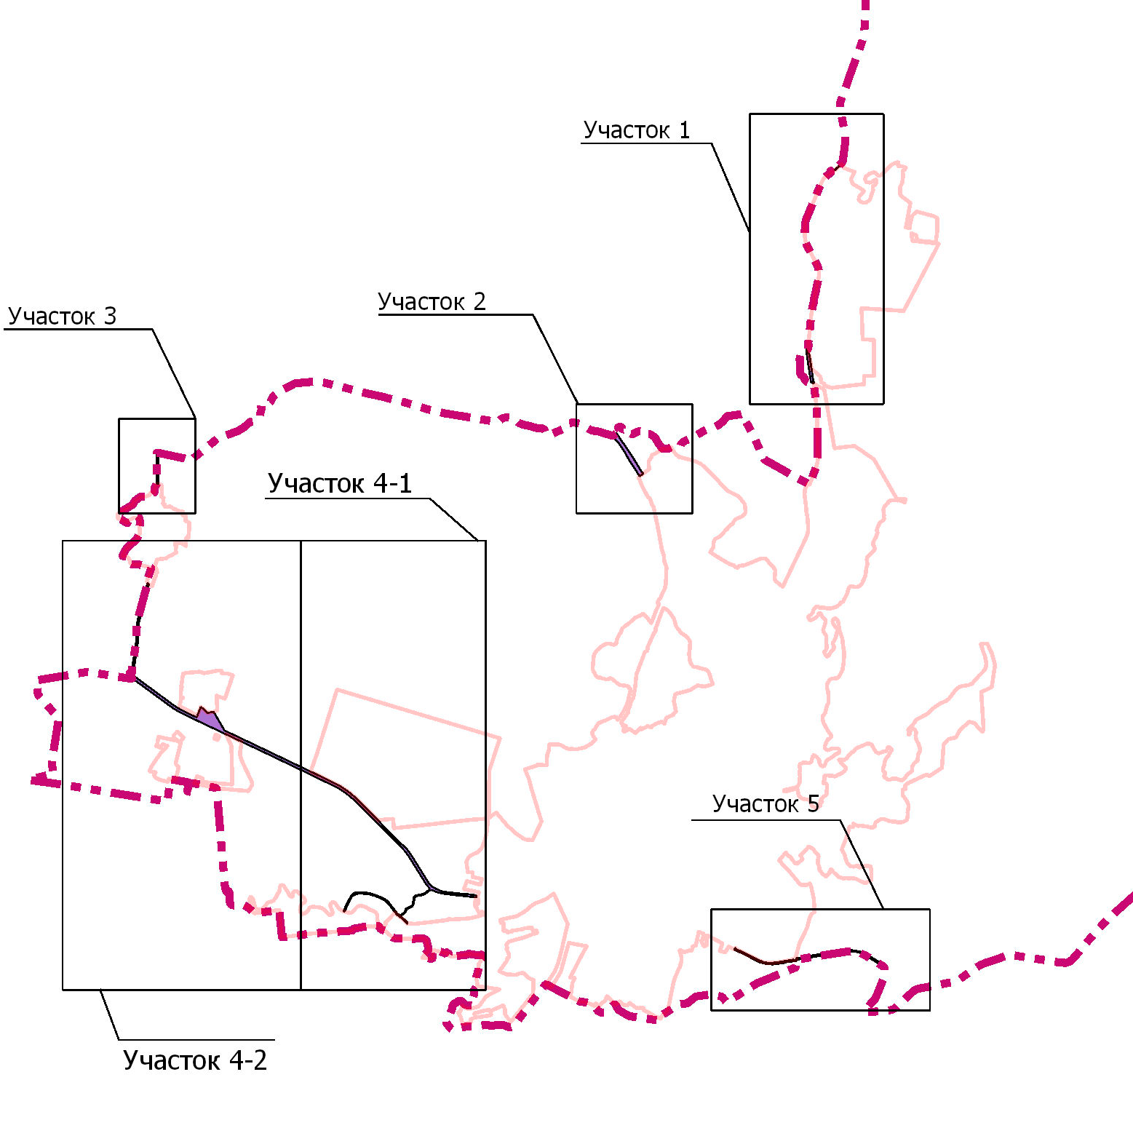

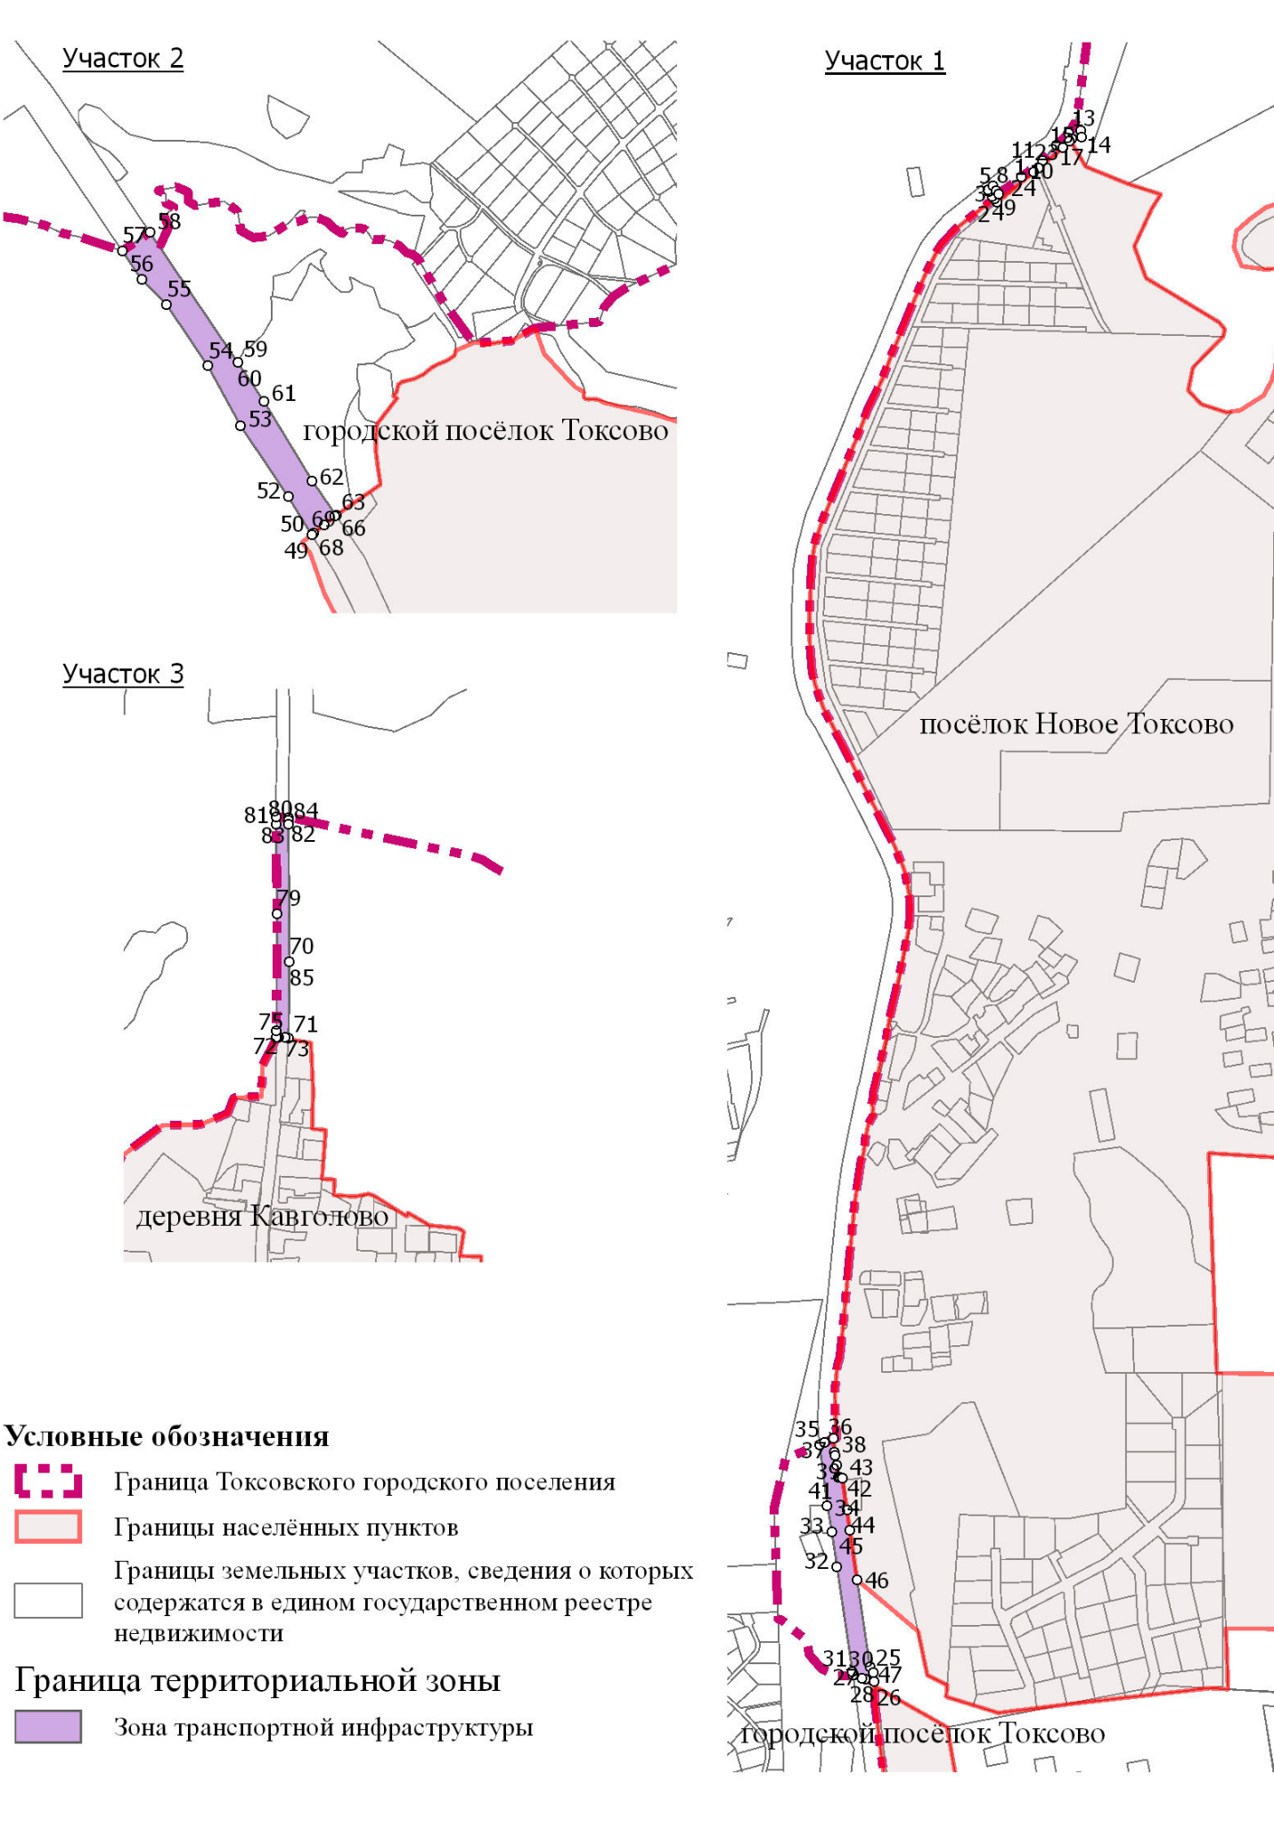
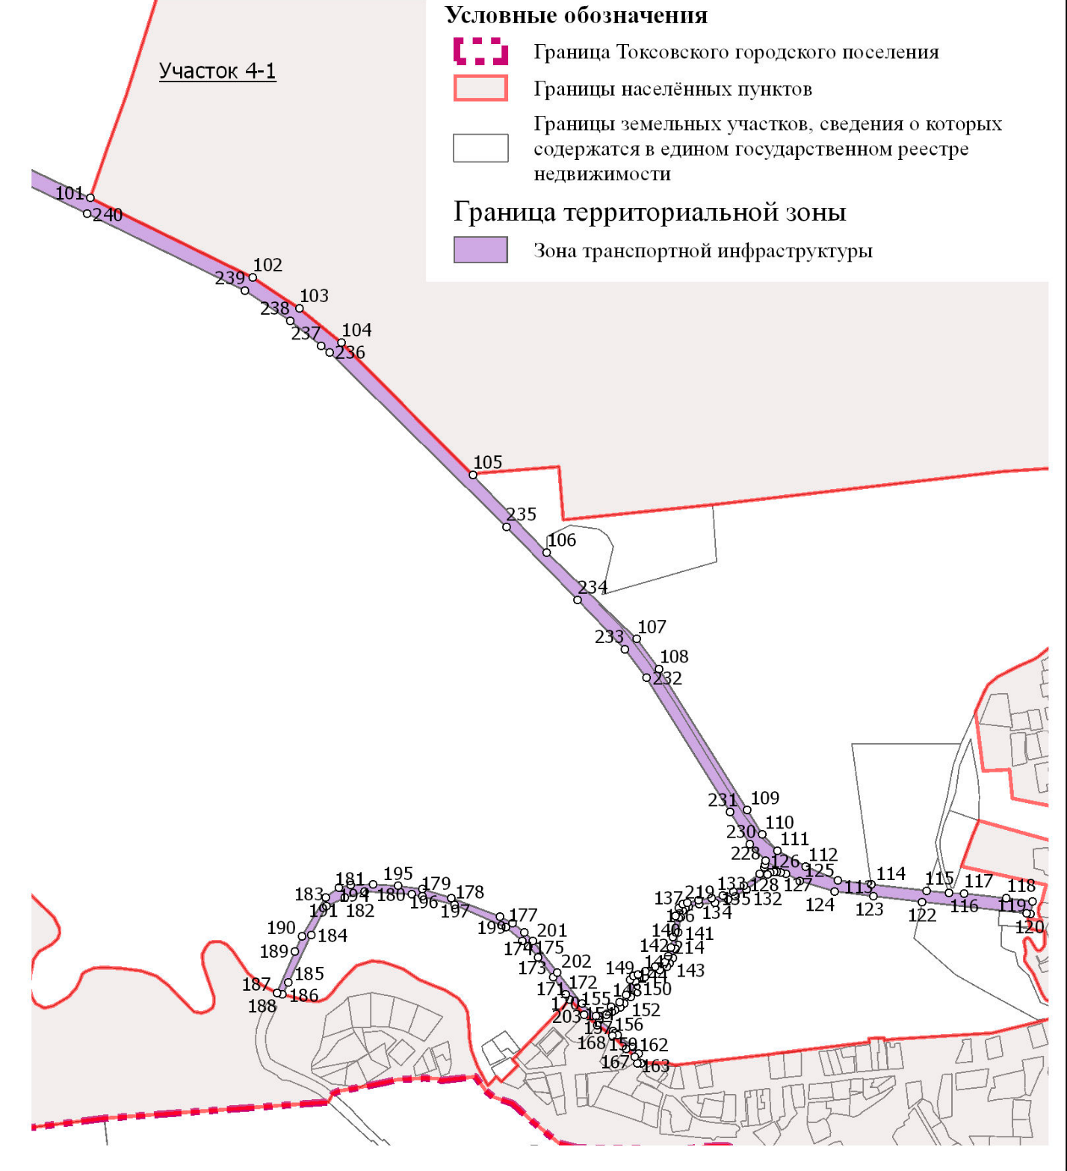
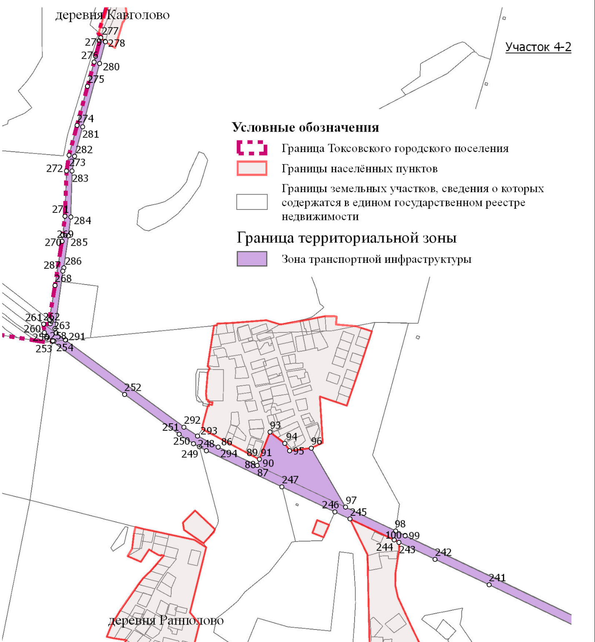
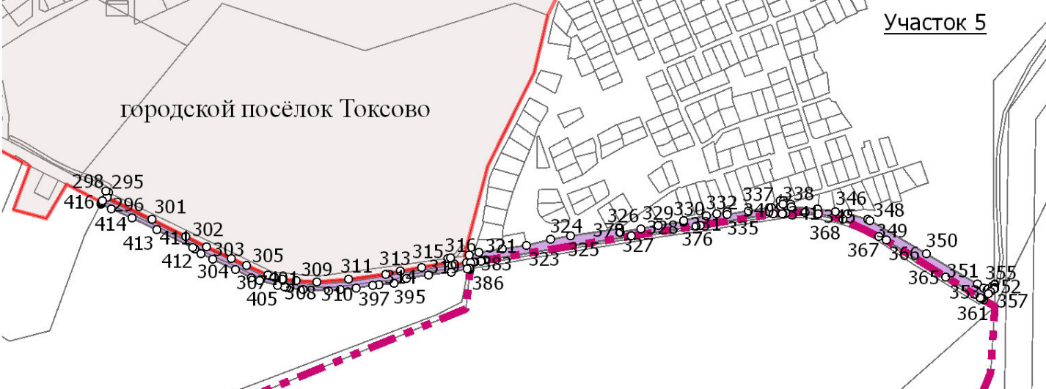
СХ-2. Зона ведения садоводства и огородничества

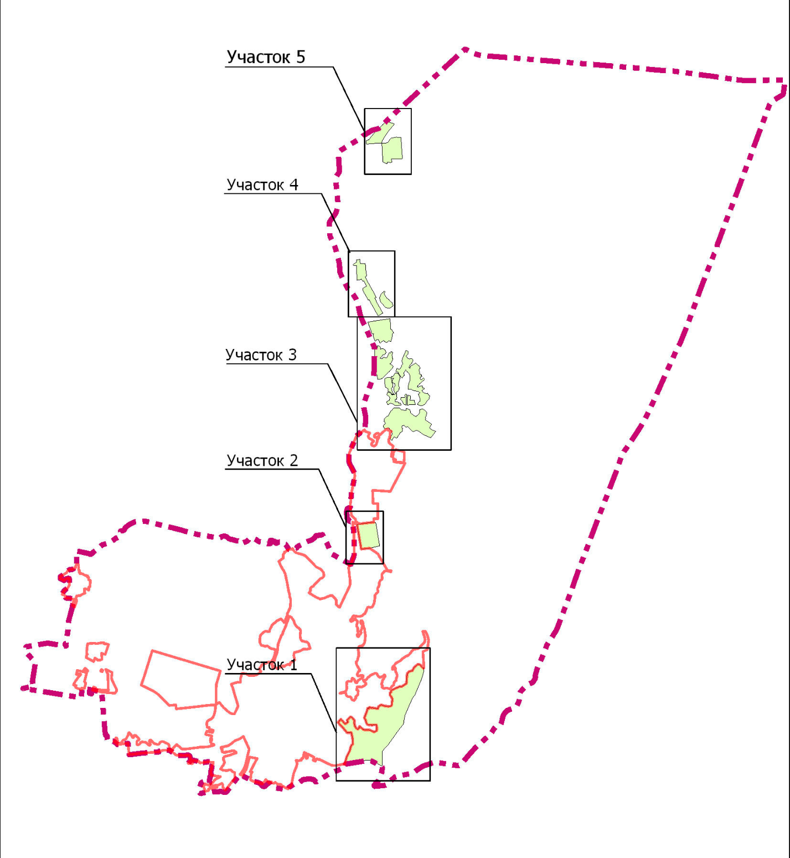

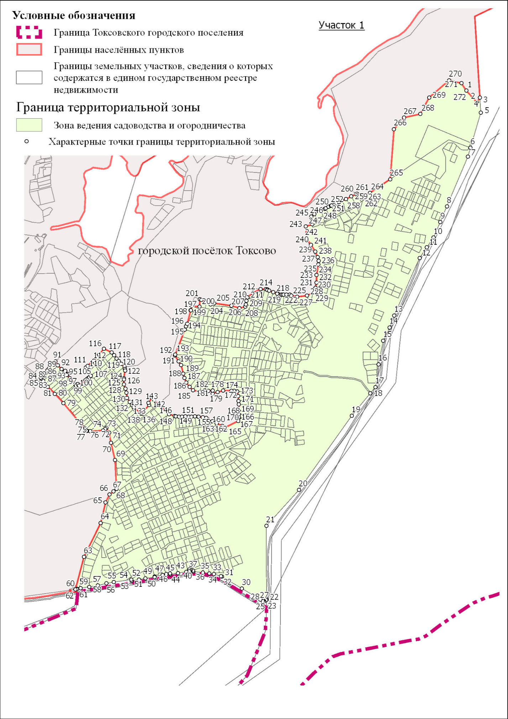

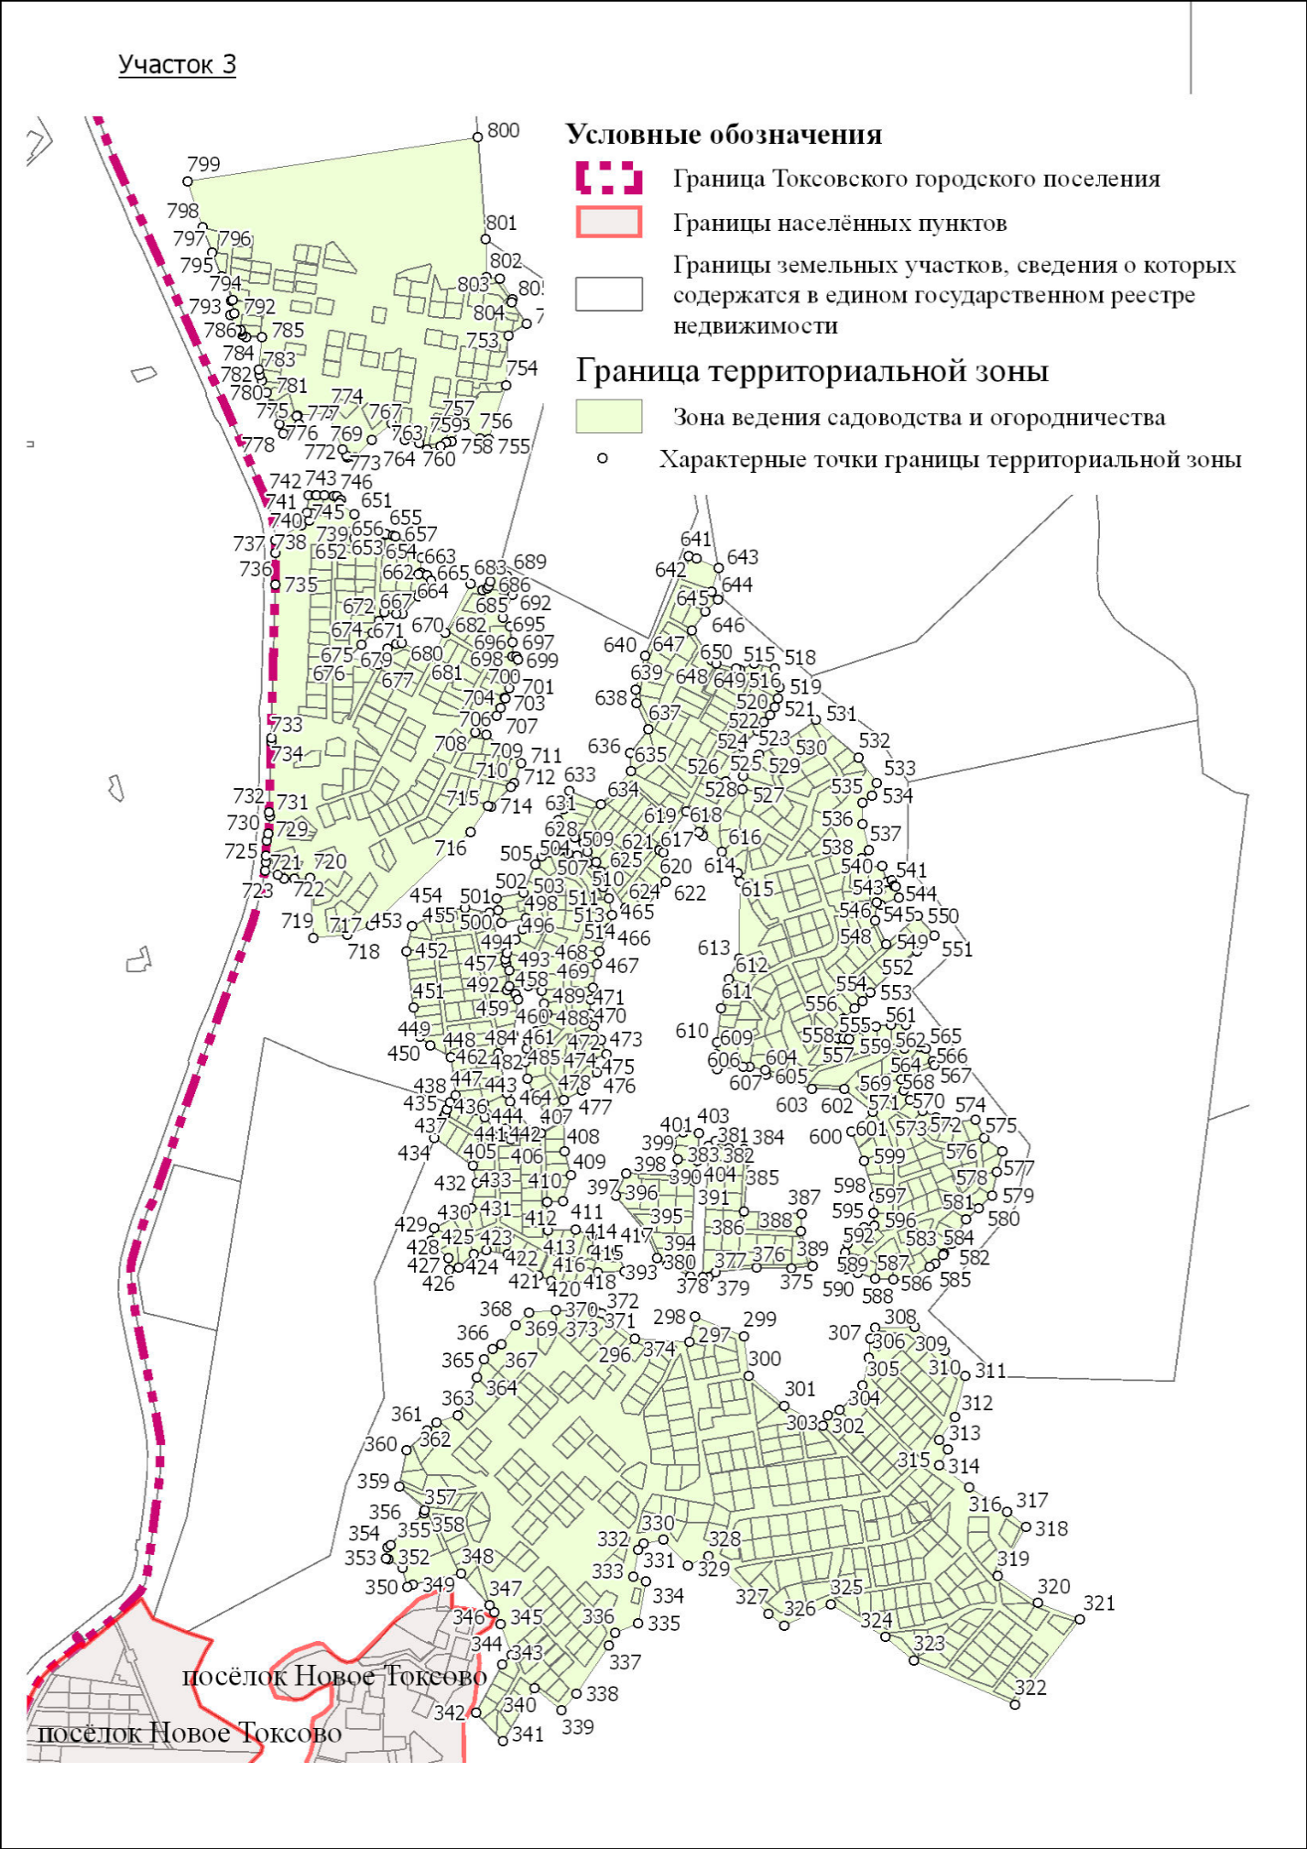

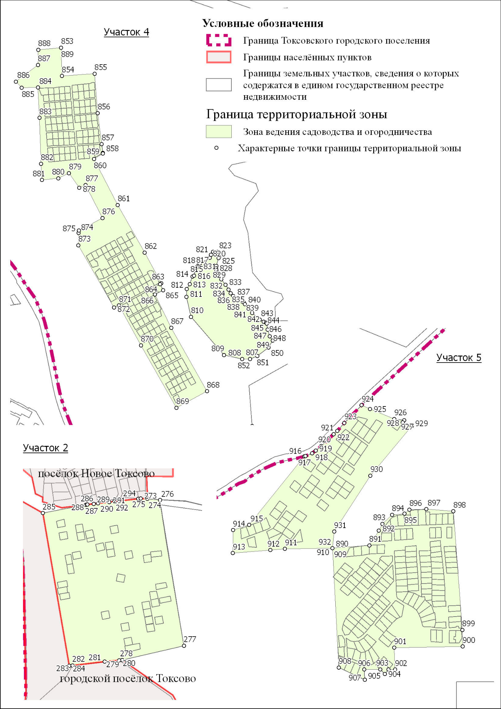

СН-1. Зона кладбищ
СН-2. Зона размещения объектов обороны и безопасности

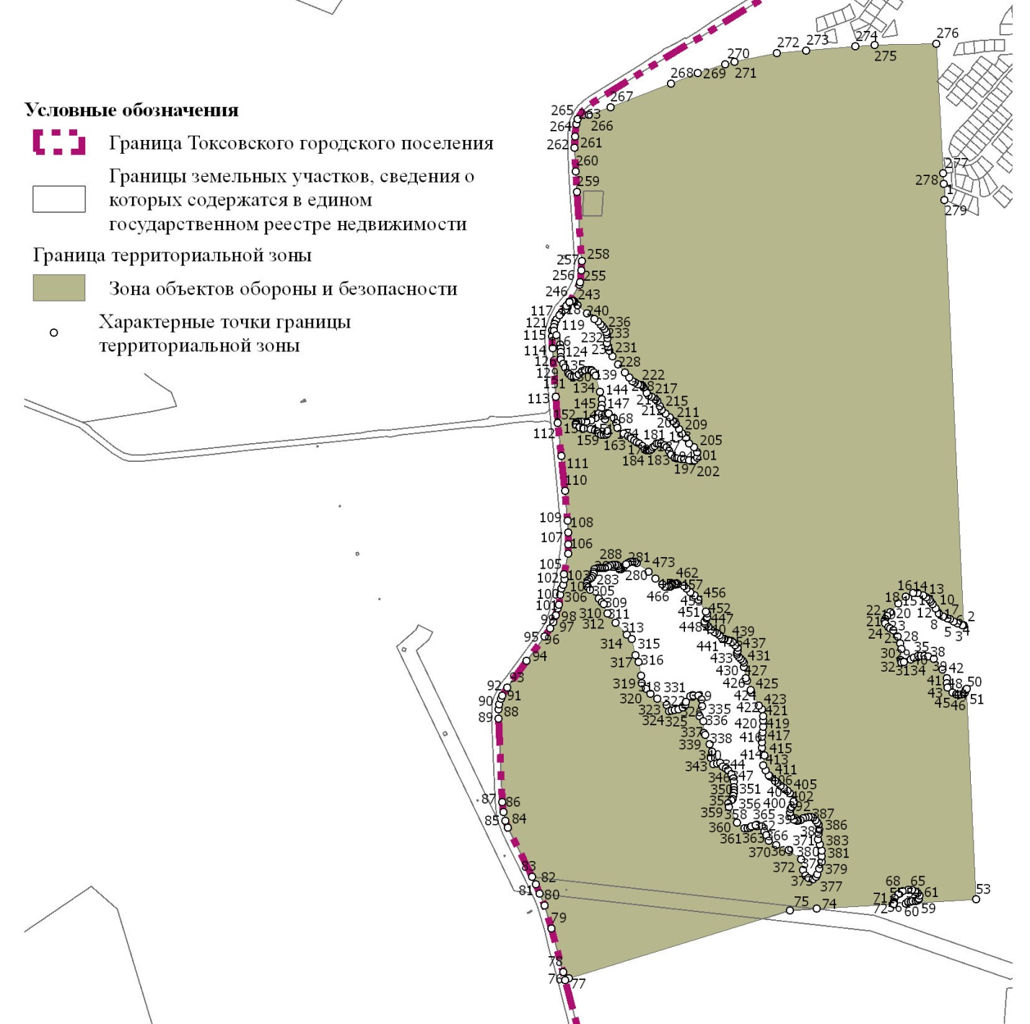

Перечень координат характерных точек границ территориальных зон

ИТ-1. Зона инженерной инфраструктуры

N | Y | X
1 | 120159,98 | 118949,00
2 | 120159,98 | 118949,00
3 | 120159,98 | 118949,00
4 | 120155,75 | 118925,10
5 | 120151,53 | 118901,20
6 | 120174,50 | 118893,98
7 | 120162,80 | 118846,10
8 | 120109,50 | 118857,75
9 | 120124,33 | 118955,03
10 | 120159,98 | 118949,00

ИТ-2. Зона транспортной инфраструктуры

N | Y | X
1 | 127236,88 | 125691,88
2 | 127179,60 | 125644,20
3 | 127174,93 | 125650,48
4 | 127172,16 | 125654,20
5 | 127166,92 | 125661,25
6 | 127164,73 | 125664,20
7 | 127172,75 | 125670,15
8 | 127178,28 | 125662,73
9 | 127181,80 | 125658,00
10 | 127217,57 | 125683,77
11 | 127249,80 | 125709,52
12 | 127271,75 | 125733,35
13 | 127290,98 | 125752,73
14 | 127309,55 | 125756,27
15 | 127311,43 | 125746,45
16 | 127295,90 | 125743,48
17 | 127292,66 | 125740,21
18 | 127281,81 | 125729,29
19 | 127281,81 | 125729,28
20 | 127281,80 | 125729,28
21 | 127281,79 | 125729,27
22 | 127281,79 | 125729,27
23 | 127244,58 | 125698,27
24 | 127236,88 | 125691,88
25 | 126986,25 | 123348,80
26 | 126987,75 | 123334,38
27 | 126973,80 | 123338,68
28 | 126968,71 | 123340,32
29 | 126955,41 | 123344,61
30 | 126954,40 | 123344,55
31 | 126953,70 | 123349,80
32 | 126929,38 | 123514,28
33 | 126921,33 | 123568,70
34 | 126914,33 | 123609,40
35 | 126902,23 | 123704,83
36 | 126910,51 | 123708,32
37 | 126923,70 | 123713,87
38 | 126925,65 | 123692,25
39 | 126926,58 | 123687,85
40 | 126928,48 | 123672,25
41 | 126931,15 | 123653,95
42 | 126934,38 | 123653,20
43 | 126937,50 | 123652,52
44 | 126944,88 | 123602,75
45 | 126949,52 | 123570,92
46 | 126960,85 | 123493,23
47 | 126980,80 | 123357,93
48 | 126986,25 | 123348,80
49 | 125073,51 | 122314,64
50 | 125073,50 | 122314,63
51 | 125073,45 | 122314,73
52 | 125036,85 | 122374,08
53 | 124962,60 | 122484,85
54 | 124911,50 | 122578,30
55 | 124846,98 | 122674,00
56 | 124807,95 | 122713,38
57 | 124777,55 | 122758,00
58 | 124820,85 | 122786,95
59 | 124958,21 | 122583,52
60 | 124958,20 | 122583,50
61 | 124998,73 | 122523,50
62 | 125074,45 | 122398,80
63 | 125111,48 | 122344,85
64 | 125111,47 | 122344,85
65 | 125111,47 | 122344,84
66 | 125109,58 | 122343,34
67 | 125092,48 | 122329,75
68 | 125077,04 | 122317,45
69 | 125073,51 | 122314,64
70 | 119791,60 | 122347,02
71 | 119790,05 | 122227,95
72 | 119784,31 | 122228,33
73 | 119774,31 | 122228,99
74 | 119772,31 | 122229,12
75 | 119772,28 | 122229,13
76 | 119772,27 | 122229,12
77 | 119771,08 | 122229,20
78 | 119771,20 | 122238,80
79 | 119771,68 | 122422,13
80 | 119770,90 | 122561,38
81 | 119770,29 | 122572,95
82 | 119789,85 | 122571,45
83 | 119789,87 | 122568,20
84 | 119789,90 | 122561,05
85 | 119791,60 | 122347,02
86 | 120077,53 | 119731,93
87 | 120212,85 | 119668,03
88 | 120219,53 | 119689,20
89 | 120219,58 | 119689,19
90 | 120219,59 | 119689,18
91 | 120219,60 | 119689,18
92 | 120219,60 | 119689,21
93 | 120256,43 | 119783,27
94 | 120307,99 | 119743,76
95 | 120324,74 | 119718,92
96 | 120398,65 | 119728,30
97 | 120517,53 | 119524,13
98 | 120689,98 | 119442,70
99 | 120723,53 | 119426,73
100 | 120723,30 | 119425,73
101 | 121462,60 | 119073,63
102 | 121776,28 | 118920,20
103 | 121866,28 | 118860,60
104 | 121947,73 | 118794,50
105 | 122201,38 | 118539,05
106 | 122344,78 | 118389,33
107 | 122518,30 | 118222,58
108 | 122561,58 | 118164,78
109 | 122732,15 | 117892,45
110 | 122760,60 | 117845,75
111 | 122789,95 | 117814,63
112 | 122844,95 | 117783,85
113 | 122906,20 | 117757,45
114 | 122970,93 | 117749,20
115 | 123078,60 | 117737,18
116 | 123121,50 | 117732,60
117 | 123150,05 | 117731,90
118 | 123232,20 | 117722,60
119 | 123282,83 | 117716,20
120 | 123279,48 | 117692,75
121 | 123271,63 | 117693,63
122 | 123069,88 | 117715,63
123 | 122974,93 | 117726,75
124 | 122899,93 | 117736,05
125 | 122833,55 | 117755,85
126 | 122806,88 | 117770,25
127 | 122795,75 | 117772,75
128 | 122788,78 | 117773,80
129 | 122783,15 | 117774,05
130 | 122775,90 | 117772,75
131 | 122770,33 | 117768,55
132 | 122730,80 | 117739,58
133 | 122708,68 | 117726,88
134 | 122694,23 | 117719,70
135 | 122668,95 | 117714,35
136 | 122639,25 | 117710,80
137 | 122618,95 | 117705,93
138 | 122612,23 | 117703,50
139 | 122607,00 | 117699,00
140 | 122603,10 | 117685,85
141 | 122598,48 | 117656,85
142 | 122592,50 | 117624,55
143 | 122588,63 | 117607,50
144 | 122581,58 | 117596,45
145 | 122576,35 | 117590,75
146 | 122563,20 | 117584,05
147 | 122547,78 | 117576,13
148 | 122533,45 | 117570,30
149 | 122522,23 | 117567,30
150 | 122518,20 | 117565,20
151 | 122515,35 | 117561,18
152 | 122506,98 | 117532,33
153 | 122494,25 | 117519,75
154 | 122486,28 | 117511,68
155 | 122476,33 | 117507,43
156 | 122469,30 | 117503,55
157 | 122460,33 | 117497,40
158 | 122445,65 | 117488,28
159 | 122471,98 | 117466,75
160 | 122476,03 | 117463,03
161 | 122481,10 | 117458,75
162 | 122510,95 | 117435,95
163 | 122521,78 | 117423,25
164 | 122526,83 | 117404,55
165 | 122519,50 | 117404,33
166 | 122514,02 | 117416,45
167 | 122497,68 | 117432,20
168 | 122471,55 | 117457,10
169 | 122441,90 | 117477,90
170 | 122417,00 | 117498,25
171 | 122389,15 | 117526,85
172 | 122381,08 | 117537,35
173 | 122356,55 | 117570,55
174 | 122328,15 | 117608,53
175 | 122308,73 | 117630,35
176 | 122296,80 | 117640,58
177 | 122265,53 | 117666,55
178 | 122166,60 | 117709,83
179 | 122103,70 | 117726,20
180 | 122084,20 | 117730,18
181 | 121992,85 | 117735,85
182 | 121954,85 | 117723,50
183 | 121918,40 | 117707,20
184 | 121888,98 | 117651,38
185 | 121845,25 | 117559,65
186 | 121834,10 | 117536,77
187 | 121822,93 | 117539,92
188 | 121822,93 | 117539,93
189 | 121858,18 | 117620,40
190 | 121871,23 | 117649,08
191 | 121916,95 | 117724,65
192 | 121942,55 | 117742,45
193 | 121965,43 | 117747,83
194 | 122008,63 | 117749,30
195 | 122056,78 | 117746,45
196 | 122104,75 | 117739,95
197 | 122160,08 | 117723,05
198 | 122253,68 | 117687,45
199 | 122278,50 | 117674,53
200 | 122301,25 | 117656,95
201 | 122317,68 | 117639,90
202 | 122364,95 | 117579,80
203 | 122412,18 | 117519,10
204 | 122439,85 | 117495,33
205 | 122468,55 | 117512,65
206 | 122485,00 | 117521,78
207 | 122498,15 | 117535,68
208 | 122506,08 | 117564,68
209 | 122512,35 | 117572,75
210 | 122520,58 | 117575,60
211 | 122535,25 | 117581,28
212 | 122553,93 | 117590,40
213 | 122572,33 | 117600,13
214 | 122579,35 | 117611,33
215 | 122583,68 | 117628,05
216 | 122588,33 | 117647,88
217 | 122593,38 | 117688,08
218 | 122599,68 | 117703,50
219 | 122607,00 | 117711,25
220 | 122616,58 | 117713,58
221 | 122637,88 | 117718,70
222 | 122662,38 | 117722,80
223 | 122684,60 | 117727,33
224 | 122705,25 | 117735,10
225 | 122725,55 | 117747,50
226 | 122755,70 | 117769,78
227 | 122764,25 | 117782,28
228 | 122766,23 | 117787,65
229 | 122766,45 | 117795,58
230 | 122736,73 | 117827,38
231 | 122698,95 | 117888,55
232 | 122536,83 | 118147,80
233 | 122495,43 | 118203,05
234 | 122404,10 | 118298,33
235 | 122266,60 | 118438,98
236 | 121924,65 | 118775,90
237 | 121908,70 | 118788,83
238 | 121848,83 | 118836,80
239 | 121761,68 | 118894,85
240 | 121456,00 | 119043,73
241 | 121012,25 | 119256,88
242 | 120825,95 | 119344,70
243 | 120701,85 | 119403,18
244 | 120685,49 | 119411,35
245 | 120532,54 | 119483,46
246 | 120480,45 | 119508,00
247 | 120298,10 | 119594,28
248 | 120037,10 | 119719,50
249 | 120013,20 | 119732,45
250 | 119992,98 | 119743,43
251 | 119942,98 | 119776,10
252 | 119755,13 | 119913,68
253 | 119505,75 | 120096,30
254 | 119511,50 | 120096,85
255 | 119511,49 | 120096,85
256 | 119507,74 | 120099,24
257 | 119488,36 | 120111,51
258 | 119485,96 | 120113,28
259 | 119478,70 | 120118,64
260 | 119477,98 | 120126,84
261 | 119475,60 | 120155,75
262 | 119498,85 | 120156,85
263 | 119498,86 | 120156,88
264 | 119499,11 | 120156,89
265 | 119502,21 | 120165,82
266 | 119498,84 | 120168,13
267 | 119495,55 | 120170,68
268 | 119515,00 | 120289,60
269 | 119538,85 | 120441,55
270 | 119542,35 | 120463,02
271 | 119549,05 | 120528,35
272 | 119555,03 | 120684,70
273 | 119563,50 | 120739,40
274 | 119590,95 | 120841,25
275 | 119627,35 | 120976,27
276 | 119649,80 | 121059,50
277 | 119672,31 | 121143,82
278 | 119687,41 | 121131,08
279 | 119688,79 | 121129,91
280 | 119668,65 | 121054,98
281 | 119610,00 | 120836,75
282 | 119582,78 | 120735,40
283 | 119574,23 | 120684,50
284 | 119569,20 | 120525,70
285 | 119561,20 | 120460,53
286 | 119545,20 | 120350,58
287 | 119542,40 | 120339,00
288 | 119514,83 | 120141,10
289 | 119519,45 | 120124,78
290 | 119552,40 | 120100,80
291 | 119551,05 | 120100,68
292 | 119960,25 | 119800,85
293 | 120007,10 | 119770,38
294 | 120077,53 | 119731,93
295 | 126123,97 | 117140,52
296 | 126128,60 | 117138,27
297 | 126127,02 | 117139,04
298 | 126128,60 | 117138,28
299 | 126128,62 | 117138,27
300 | 126125,66 | 117129,14
301 | 126209,01 | 117088,44
302 | 126270,74 | 117057,69
303 | 126309,50 | 117038,13
304 | 126354,29 | 117017,13
305 | 126382,53 | 117004,08
306 | 126422,06 | 116986,42
307 | 126433,80 | 116982,18
308 | 126449,09 | 116978,35
309 | 126474,66 | 116975,59
310 | 126512,66 | 116973,51
311 | 126570,72 | 116978,23
312 | 126639,81 | 116988,02
313 | 126666,18 | 116993,16
314 | 126705,39 | 117000,48
315 | 126754,00 | 117008,89
316 | 126753,25 | 117016,72
317 | 126759,18 | 117017,54
318 | 126761,00 | 117004,33
319 | 126788,23 | 117008,75
320 | 126792,93 | 117023,40
321 | 126810,45 | 117028,02
322 | 126853,55 | 117034,25
323 | 126898,13 | 117040,77
324 | 126942,35 | 117051,82
325 | 126979,52 | 117058,38
326 | 127069,48 | 117071,85
327 | 127070,60 | 117065,18
328 | 127108,70 | 117071,60
329 | 127140,73 | 117077,15
330 | 127188,48 | 117084,18
331 | 127187,88 | 117086,93
332 | 127229,35 | 117095,55
333 | 127248,25 | 117098,95
334 | 127267,25 | 117102,35
335 | 127268,02 | 117097,90
336 | 127307,75 | 117104,43
337 | 127349,10 | 117110,98
338 | 127366,02 | 117113,10
339 | 127367,43 | 117113,29
340 | 127366,21 | 117123,69
341 | 127371,96 | 117123,06
342 | 127371,25 | 117116,60
343 | 127384,08 | 117117,25
344 | 127386,10 | 117112,23
345 | 127434,78 | 117107,53
346 | 127467,28 | 117103,28
347 | 127490,38 | 117099,63
348 | 127526,45 | 117088,45
349 | 127531,38 | 117086,50
350 | 127634,53 | 117025,53
351 | 127728,31 | 116969,53
352 | 127740,75 | 116962,10
353 | 127747,12 | 116958,30
354 | 127749,15 | 116960,13
355 | 127757,40 | 116966,35
356 | 127760,55 | 116968,82
357 | 127760,62 | 116963,45
358 | 127760,64 | 116961,28
359 | 127752,98 | 116955,48
360 | 127748,73 | 116951,68
361 | 127739,73 | 116940,78
362 | 127737,14 | 116942,34
363 | 127737,07 | 116942,38
364 | 127734,55 | 116943,90
365 | 127671,00 | 116982,20
366 | 127560,85 | 117050,27
367 | 127547,58 | 117056,70
368 | 127481,70 | 117088,60
369 | 127435,80 | 117099,55
370 | 127411,35 | 117102,02
371 | 127376,15 | 117100,00
372 | 127370,98 | 117099,68
373 | 127370,50 | 117099,66
374 | 127370,00 | 117099,63
375 | 127352,70 | 117098,63
376 | 127218,02 | 117077,85
377 | 127210,40 | 117076,45
378 | 127091,05 | 117057,88
379 | 126823,87 | 117013,67
380 | 126823,03 | 117013,53
381 | 126816,04 | 117012,37
382 | 126814,13 | 117012,06
383 | 126802,95 | 117010,21
384 | 126800,88 | 117009,87
385 | 126795,80 | 117009,02
386 | 126794,46 | 116996,27
387 | 126794,68 | 116998,48
388 | 126792,73 | 116998,23
389 | 126789,38 | 116997,55
390 | 126789,37 | 116997,55
391 | 126789,35 | 116997,55
392 | 126759,80 | 116991,63
393 | 126718,05 | 116986,68
394 | 126677,75 | 116980,25
395 | 126654,18 | 116970,68
396 | 126626,25 | 116968,45
397 | 126615,05 | 116967,10
398 | 126584,02 | 116962,48
399 | 126555,20 | 116959,05
400 | 126533,68 | 116957,50
401 | 126487,15 | 116959,60
402 | 126462,25 | 116962,30
403 | 126456,87 | 116963,45
404 | 126452,07 | 116964,48
405 | 126439,46 | 116967,66
406 | 126406,80 | 116975,90
407 | 126392,07 | 116980,68
408 | 126361,73 | 116996,30
409 | 126320,15 | 117015,00
410 | 126299,48 | 117025,23
411 | 126287,64 | 117033,85
412 | 126283,18 | 117037,10
413 | 126217,15 | 117069,45
414 | 126172,48 | 117091,05
415 | 126133,59 | 117108,54
416 | 126114,85 | 117116,98
417 | 126115,22 | 117118,03
418 | 126115,57 | 117119,02
419 | 126115,65 | 117120,34
420 | 126115,65 | 117120,40
421 | 126116,93 | 117122,90
422 | 126123,18 | 117140,90
423 | 126123,97 | 117140,52

ОД-1. Зона делового, общественного и коммерческого назначения

N | Y | X
1 | 126929,38 | 123514,28
2 | 126834,88 | 123497,75
3 | 126834,19 | 123515,90
4 | 126834,10 | 123518,30
5 | 126830,85 | 123603,95
6 | 126849,13 | 123682,47
7 | 126859,43 | 123686,81
8 | 126870,01 | 123691,27
9 | 126888,91 | 123699,22
10 | 126902,23 | 123704,83
11 | 126914,33 | 123609,40
12 | 126921,33 | 123568,70
13 | 126929,38 | 123514,28

СХ-1. Зона сельскохозяйственного производства

N | Y | X
1 | 120532,54 | 119483,45
2 | 120564,31 | 119418,70
3 | 120592,65 | 119360,90
4 | 120592,91 | 119350,23
5 | 120602,84 | 118932,60
6 | 120271,50 | 118958,80
7 | 120276,82 | 118996,31
8 | 120216,87 | 119024,59
9 | 120184,58 | 118947,28
10 | 120185,23 | 118943,69
11 | 120159,98 | 118949,00
12 | 120124,33 | 118955,03
13 | 120079,85 | 118962,79
14 | 120079,79 | 118962,80
15 | 120081,15 | 118965,40
16 | 120126,48 | 119049,80
17 | 120062,40 | 119092,45
18 | 120072,73 | 119141,23
19 | 120144,60 | 119199,68
20 | 120169,75 | 119231,70
21 | 120253,25 | 119299,35
22 | 120317,55 | 119380,80
23 | 120331,43 | 119403,63
24 | 120344,55 | 119406,28
25 | 120436,20 | 119408,98
26 | 120441,43 | 119420,68
27 | 120441,43 | 119420,68
28 | 120460,40 | 119463,10
29 | 120480,45 | 119508,00
30 | 120532,54 | 119483,45
31 | 120407,63 | 118970,10
32 | 120438,48 | 118965,58
33 | 120442,25 | 118970,10
34 | 120443,75 | 118984,40
35 | 120442,23 | 119001,70
36 | 120434,70 | 119004,70
37 | 120424,93 | 119011,45
38 | 120418,90 | 119018,98
39 | 120410,63 | 119020,48
40 | 120400,85 | 119013,70
41 | 120396,35 | 119001,68
42 | 120391,08 | 118990,40
43 | 120382,80 | 118983,63
44 | 120379,05 | 118976,10
45 | 120382,05 | 118973,10
46 | 120391,08 | 118971,60
47 | 120407,63 | 118970,10

СХ-2. Зона ведения садоводства и огородничества

N | Y | X
1 | 128780,30 | 119567,50
2 | 128834,80 | 119508,60
3 | 128849,92 | 119531,35
4 | 128849,93 | 119531,33
5 | 128854,70 | 119455,10
6 | 128802,00 | 119275,88
7 | 128788,63 | 119230,43
8 | 128681,50 | 118975,95
9 | 128648,30 | 118896,03
10 | 128613,73 | 118817,70
11 | 128578,18 | 118767,05
12 | 128541,88 | 118712,13
13 | 128412,95 | 118419,80
14 | 128388,63 | 118358,88
15 | 128356,10 | 118290,65
16 | 128332,13 | 118169,98
17 | 128316,10 | 118054,33
18 | 128290,15 | 118022,85
19 | 128195,10 | 117907,55
20 | 127925,40 | 117528,88
21 | 127759,05 | 117345,28
22 | 127760,57 | 116968,86
23 | 127760,55 | 116968,85
24 | 127760,55 | 116968,82
25 | 127757,40 | 116966,35
26 | 127749,15 | 116960,13
27 | 127747,12 | 116958,30
28 | 127740,75 | 116962,10
29 | 127728,31 | 116969,53
30 | 127634,53 | 117025,53
31 | 127531,38 | 117086,50
32 | 127526,45 | 117088,45
33 | 127490,38 | 117099,63
34 | 127467,28 | 117103,28
35 | 127434,78 | 117107,53
36 | 127386,10 | 117112,23
37 | 127384,08 | 117117,25
38 | 127371,25 | 117116,60
39 | 127371,96 | 117123,06
40 | 127366,21 | 117123,69
41 | 127367,43 | 117113,29
42 | 127366,02 | 117113,10
43 | 127349,10 | 117110,98
44 | 127307,75 | 117104,43
45 | 127268,02 | 117097,90
46 | 127267,25 | 117102,35
47 | 127248,25 | 117098,95
48 | 127229,35 | 117095,55
49 | 127187,88 | 117086,93
50 | 127188,48 | 117084,18
51 | 127140,73 | 117077,15
52 | 127108,70 | 117071,60
53 | 127070,60 | 117065,18
54 | 127069,48 | 117071,85
55 | 126979,52 | 117058,38
56 | 126942,35 | 117051,82
57 | 126898,13 | 117040,77
58 | 126853,55 | 117034,25
59 | 126810,45 | 117028,02
60 | 126792,93 | 117023,40
61 | 126791,73 | 117023,08
62 | 126783,48 | 117020,88
63 | 126827,05 | 117187,20
64 | 126912,65 | 117359,92
65 | 126937,63 | 117465,37
66 | 126957,70 | 117505,45
67 | 126978,48 | 117521,87
68 | 126993,28 | 117533,55
69 | 126985,90 | 117680,95
70 | 126964,90 | 117769,33
71 | 126955,52 | 117821,30
72 | 126941,15 | 117845,77
73 | 126934,87 | 117840,30
74 | 126924,75 | 117832,48
75 | 126858,72 | 117828,60
76 | 126843,18 | 117831,55
77 | 126839,67 | 117830,89
78 | 126830,80 | 117841,58
79 | 126722,13 | 117972,52
80 | 126678,33 | 118019,50
81 | 126641,85 | 118055,80
82 | 126618,20 | 118085,90
83 | 126608,96 | 118097,70
84 | 126605,60 | 118101,97
85 | 126605,60 | 118101,98
86 | 126624,23 | 118119,69
87 | 126629,77 | 118124,96
88 | 126635,06 | 118131,89
89 | 126641,03 | 118139,71
90 | 126648,18 | 118149,50
91 | 126680,92 | 118185,97
92 | 126693,25 | 118165,50
93 | 126712,40 | 118146,18
94 | 126726,18 | 118132,30
95 | 126731,20 | 118137,35
96 | 126745,33 | 118121,08
97 | 126740,08 | 118116,05
98 | 126754,33 | 118099,90
99 | 126781,42 | 118069,25
100 | 126787,08 | 118062,85
101 | 126795,25 | 118070,02
102 | 126801,85 | 118062,15
103 | 126834,02 | 118088,83
104 | 126841,30 | 118094,75
105 | 126849,07 | 118101,07
106 | 126853,12 | 118104,35
107 | 126862,40 | 118111,87
108 | 126846,70 | 118130,43
109 | 126851,55 | 118134,50
110 | 126837,35 | 118153,35
111 | 126845,43 | 118162,20
112 | 126868,40 | 118184,65
113 | 126877,50 | 118187,90
114 | 126895,57 | 118210,60
115 | 126903,48 | 118220,55
116 | 126929,70 | 118249,60
117 | 126968,93 | 118230,43
118 | 126981,62 | 118217,53
119 | 126993,88 | 118200,21
120 | 127005,13 | 118186,70
121 | 127016,45 | 118173,35
122 | 127033,60 | 118157,17
123 | 127036,65 | 118146,90
124 | 127036,95 | 118138,00
125 | 127030,45 | 118098,75
126 | 127030,50 | 118098,60
127 | 127030,52 | 118092,65
128 | 127030,61 | 118067,61
129 | 127038,75 | 118045,60
130 | 127044,58 | 118025,68
131 | 127047,55 | 117998,02
132 | 127061,15 | 117978,45
133 | 127072,05 | 117963,52
134 | 127074,37 | 117960,77
135 | 127081,98 | 117951,10
136 | 127119,67 | 117919,45
137 | 127119,70 | 117919,45
138 | 127119,72 | 117919,49
139 | 127119,73 | 117919,50
140 | 127119,75 | 117919,55
141 | 127121,11 | 117920,97
142 | 127160,27 | 117961,85
143 | 127157,40 | 117973,55
144 | 127174,10 | 118000,05
145 | 127184,45 | 117990,02
146 | 127205,50 | 117966,40
147 | 127261,18 | 117916,12
148 | 127289,50 | 117906,70
149 | 127296,40 | 117903,88
150 | 127311,80 | 117902,90
151 | 127327,75 | 117903,60
152 | 127345,00 | 117904,80
153 | 127361,88 | 117903,15
154 | 127376,83 | 117903,58
155 | 127393,80 | 117904,05
156 | 127411,15 | 117902,85
157 | 127413,15 | 117902,73
158 | 127434,48 | 117900,45
159 | 127452,00 | 117896,23
160 | 127464,07 | 117887,40
161 | 127483,15 | 117879,80
162 | 127501,68 | 117874,15
163 | 127505,95 | 117868,80
164 | 127532,95 | 117855,93
165 | 127549,18 | 117848,20
166 | 127614,37 | 117880,85
167 | 127617,43 | 117896,83
168 | 127618,22 | 117900,95
169 | 127618,30 | 117915,75
170 | 127618,38 | 117932,10
171 | 127618,78 | 117965,08
172 | 127617,02 | 117982,42
173 | 127614,45 | 118008,18
174 | 127609,87 | 118031,05
175 | 127596,80 | 118031,47
176 | 127593,93 | 118035,55
177 | 127581,22 | 118035,57
178 | 127538,43 | 118035,65
179 | 127510,15 | 118028,92
180 | 127484,17 | 118021,42
181 | 127484,32 | 118037,02
182 | 127462,55 | 118035,02
183 | 127444,60 | 118036,50
184 | 127420,40 | 118030,35
185 | 127384,40 | 118037,23
186 | 127367,20 | 118054,50
187 | 127349,38 | 118077,35
188 | 127340,58 | 118101,20
189 | 127334,75 | 118122,95
190 | 127323,22 | 118166,38
191 | 127310,83 | 118185,22
192 | 127291,72 | 118214,58
193 | 127293,37 | 118220,17
194 | 127342,36 | 118347,70
195 | 127348,96 | 118364,21
196 | 127354,78 | 118377,67
197 | 127372,52 | 118445,73
198 | 127372,60 | 118446,07
199 | 127377,18 | 118467,95
200 | 127417,33 | 118464,37
201 | 127419,60 | 118502,20
202 | 127426,83 | 118499,43
203 | 127449,25 | 118488,10
204 | 127474,10 | 118475,02
205 | 127492,35 | 118482,10
206 | 127580,65 | 118469,30
207 | 127621,85 | 118457,30
208 | 127651,40 | 118464,07
209 | 127654,40 | 118475,68
210 | 127656,97 | 118494,40
211 | 127661,73 | 118512,35
212 | 127690,50 | 118535,05
213 | 127729,85 | 118554,37
214 | 127755,88 | 118554,35
215 | 127764,58 | 118552,00
216 | 127764,40 | 118549,15
217 | 127773,45 | 118546,63
218 | 127794,05 | 118538,02
219 | 127815,80 | 118533,60
220 | 127814,75 | 118530,67
221 | 127834,60 | 118526,55
222 | 127840,50 | 118526,40
223 | 127847,68 | 118526,23
224 | 127861,78 | 118525,83
225 | 127879,30 | 118525,50
226 | 127885,83 | 118522,00
227 | 127917,00 | 118514,98
228 | 127967,13 | 118520,70
229 | 128003,65 | 118540,12
230 | 128005,70 | 118555,90
231 | 128010,60 | 118559,98
232 | 128015,95 | 118586,53
233 | 128015,45 | 118625,70
234 | 128015,45 | 118625,90
235 | 128015,47 | 118626,00
236 | 128025,15 | 118679,95
237 | 128025,77 | 118697,90
238 | 128021,17 | 118718,13
239 | 128009,17 | 118745,15
240 | 127987,57 | 118780,25
241 | 127987,33 | 118780,63
242 | 127963,35 | 118812,35
243 | 127960,75 | 118874,50
244 | 127992,90 | 118884,70
245 | 127986,70 | 118916,50
246 | 127988,75 | 118924,35
247 | 128004,25 | 118936,70
248 | 128039,02 | 118957,05
249 | 128057,62 | 118964,47
250 | 128062,70 | 118967,02
251 | 128076,95 | 118974,20
252 | 128089,55 | 118980,00
253 | 128092,30 | 118981,25
254 | 128109,80 | 118989,23
255 | 128116,87 | 118992,45
256 | 128129,38 | 118998,10
257 | 128145,60 | 119005,68
258 | 128166,00 | 119013,40
259 | 128193,15 | 119027,58
260 | 128217,82 | 119038,95
261 | 128222,60 | 119041,15
262 | 128256,35 | 119024,05
263 | 128262,45 | 119028,18
264 | 128287,97 | 119045,46
265 | 128391,79 | 119115,19
266 | 128411,20 | 119370,58
267 | 128461,98 | 119429,53
268 | 128545,33 | 119448,05
269 | 128590,98 | 119532,37
270 | 128692,83 | 119620,35
271 | 128755,68 | 119605,15
272 | 128780,30 | 119567,50
273 | 127511,85 | 123324,37
274 | 127539,95 | 123322,70
275 | 127539,95 | 123322,75
276 | 127592,50 | 123317,68
277 | 127692,75 | 122707,25
278 | 127434,33 | 122647,53
279 | 127434,14 | 122647,51
280 | 127421,90 | 122646,45
281 | 127360,15 | 122641,18
282 | 127225,65 | 122624,62
283 | 127225,62 | 122624,62
284 | 127212,22 | 122622,97
285 | 127101,40 | 123263,30
286 | 127282,10 | 123297,68
287 | 127286,28 | 123298,62
288 | 127288,52 | 123298,90
289 | 127315,00 | 123302,13
290 | 127333,08 | 123304,18
291 | 127379,95 | 123309,48
292 | 127401,77 | 123311,95
293 | 127420,75 | 123314,10
294 | 127501,90 | 123323,25
295 | 127511,85 | 123324,37
296 | 128273,93 | 126256,55
297 | 128382,15 | 126249,26
298 | 128394,38 | 126299,45
299 | 128490,58 | 126261,20
300 | 128500,08 | 126183,05
301 | 128571,15 | 126123,30
302 | 128647,75 | 126083,53
303 | 128657,63 | 126103,85
304 | 128681,58 | 126115,25
305 | 128727,13 | 126163,65
306 | 128739,15 | 126218,85
307 | 128742,08 | 126255,70
308 | 128751,98 | 126277,70
309 | 128830,40 | 126279,20
310 | 128889,13 | 126232,03
311 | 128930,73 | 126183,10
312 | 128909,28 | 126100,58
313 | 128879,08 | 126054,68
314 | 128896,60 | 126035,90
315 | 128878,78 | 126005,30
316 | 128938,13 | 125960,98
317 | 129014,25 | 125913,13
318 | 129051,15 | 125882,93
319 | 128994,15 | 125785,65
320 | 129074,65 | 125731,33
321 | 129158,50 | 125699,13
322 | 129029,03 | 125530,08
323 | 128827,78 | 125617,28
324 | 128771,48 | 125663,90
325 | 128662,98 | 125728,80
326 | 128570,45 | 125686,38
327 | 128539,38 | 125710,18
328 | 128420,73 | 125824,60
329 | 128380,03 | 125805,93
330 | 128331,23 | 125856,75
331 | 128291,43 | 125849,15
332 | 128281,15 | 125836,78
333 | 128271,90 | 125783,65
334 | 128296,38 | 125774,45
335 | 128281,33 | 125691,18
336 | 128234,55 | 125671,63
337 | 128223,10 | 125646,93
338 | 128158,23 | 125550,85
339 | 128129,25 | 125517,80
340 | 128075,13 | 125562,75
341 | 128012,03 | 125456,60
342 | 127958,58 | 125513,40
343 | 128011,45 | 125609,85
344 | 128030,38 | 125627,68
345 | 128007,75 | 125688,80
346 | 127995,55 | 125713,45
347 | 127985,60 | 125726,70
348 | 127929,45 | 125790,05
349 | 127833,55 | 125767,93
350 | 127822,13 | 125763,50
351 | 127812,70 | 125800,75
352 | 127785,00 | 125818,10
353 | 127780,33 | 125819,65
354 | 127782,60 | 125842,30
355 | 127789,83 | 125847,15
356 | 127817,20 | 125879,28
357 | 127856,00 | 125908,90
358 | 127857,75 | 125915,43
359 | 127806,33 | 125962,35
360 | 127820,90 | 126034,08
361 | 127862,13 | 126074,20
362 | 127880,93 | 126090,10
363 | 127923,30 | 126104,65
364 | 127960,38 | 126179,73
365 | 127974,10 | 126215,45
366 | 127991,90 | 126235,03
367 | 128009,63 | 126245,20
368 | 128037,80 | 126282,83
369 | 128063,95 | 126308,50
370 | 128117,05 | 126312,15
371 | 128196,25 | 126313,15
372 | 128201,95 | 126308,60
373 | 128209,15 | 126307,08
374 | 128273,93 | 126256,55
375 | 128627,33 | 126400,93
376 | 128585,73 | 126395,90
377 | 128515,40 | 126396,93
378 | 128434,10 | 126388,58
379 | 128420,03 | 126378,45
380 | 128408,85 | 126379,20
381 | 128420,95 | 126638,75
382 | 128435,28 | 126647,73
383 | 128461,65 | 126634,00
384 | 128490,75 | 126633,25
385 | 128498,15 | 126608,55
386 | 128491,50 | 126509,25
387 | 128605,65 | 126503,78
388 | 128603,95 | 126468,80
389 | 128627,33 | 126400,93
390 | 128399,03 | 126610,00
391 | 128392,63 | 126568,45
392 | 128383,85 | 126380,85
393 | 128338,75 | 126401,88
394 | 128319,03 | 126416,45
395 | 128297,93 | 126466,03
396 | 128236,35 | 126539,85
397 | 128256,75 | 126584,78
398 | 128354,05 | 126580,15
399 | 128359,18 | 126611,93
400 | 128347,40 | 126640,20
401 | 128347,40 | 126647,30
402 | 128370,03 | 126666,43
403 | 128402,15 | 126664,90
404 | 128399,03 | 126610,00
405 | 128006,03 | 126658,90
406 | 128028,65 | 126651,85
407 | 128086,98 | 126663,70
408 | 128132,73 | 126689,63
409 | 128135,00 | 126628,10
410 | 128147,05 | 126580,33
411 | 128131,10 | 126529,05
412 | 128099,58 | 126528,20
413 | 128101,10 | 126470,85
414 | 128157,18 | 126472,33
415 | 128190,35 | 126459,80
416 | 128189,45 | 126431,58
417 | 128239,05 | 126429,88
418 | 128254,60 | 126390,25
419 | 128200,10 | 126388,08
420 | 128184,60 | 126367,85
421 | 128107,63 | 126370,70
422 | 128082,53 | 126382,38
423 | 128021,25 | 126423,88
424 | 127979,90 | 126431,15
425 | 127954,90 | 126424,18
426 | 127924,65 | 126397,73
427 | 127906,40 | 126392,60
428 | 127903,53 | 126415,65
429 | 127869,75 | 126450,58
430 | 127876,03 | 126475,18
431 | 127948,98 | 126514,55
432 | 127960,05 | 126564,65
433 | 127952,33 | 126599,05
434 | 127876,60 | 126655,43
435 | 127893,62 | 126694,28
436 | 127897,26 | 126702,59
437 | 127901,17 | 126711,89
438 | 127906,58 | 126724,78
439 | 127935,98 | 126715,99
440 | 127959,15 | 126709,05
441 | 127977,05 | 126694,93
442 | 128006,03 | 126658,90
443 | 128027,20 | 126726,50
444 | 128067,33 | 126670,70
445 | 128018,88 | 126673,00
446 | 127975,00 | 126721,53
447 | 127918,98 | 126738,75
448 | 127909,35 | 126815,50
449 | 127868,40 | 126837,68
450 | 127847,68 | 126854,95
451 | 127834,45 | 126913,40
452 | 127820,38 | 127025,63
453 | 127832,30 | 127074,88
454 | 127884,88 | 127102,90
455 | 127936,58 | 127111,58
456 | 127985,85 | 127101,40
457 | 128019,08 | 127001,33
458 | 128019,73 | 126948,55
459 | 128037,60 | 126939,63
460 | 128041,58 | 126929,38
461 | 128033,28 | 126860,83
462 | 128002,53 | 126822,63
463 | 128020,58 | 126742,15
464 | 128027,20 | 126726,50
465 | 128228,60 | 127097,63
466 | 128223,58 | 127072,30
467 | 128204,55 | 127024,55
468 | 128198,48 | 127000,18
469 | 128191,24 | 126952,64
470 | 128186,45 | 126928,80
471 | 128184,43 | 126901,63
472 | 128193,35 | 126877,55
473 | 128206,55 | 126849,66
474 | 128217,70 | 126821,65
475 | 128189,73 | 126810,30
476 | 128199,03 | 126785,03
477 | 128169,88 | 126749,10
478 | 128133,35 | 126730,15
479 | 128132,73 | 126706,35
480 | 128099,48 | 126692,90
481 | 128074,09 | 126742,83
482 | 128060,33 | 126773,15
483 | 128056,90 | 126805,08
484 | 128058,88 | 126832,30
485 | 128062,08 | 126847,58
486 | 128078,24 | 126866,06
487 | 128094,75 | 126886,90
488 | 128100,05 | 126901,03
489 | 128093,23 | 126922,25
490 | 128088,65 | 126947,15
491 | 128061,95 | 126956,23
492 | 128024,80 | 126955,70
493 | 128024,83 | 126987,40
494 | 128017,18 | 127010,18
495 | 128020,65 | 127021,45
496 | 128037,52 | 127049,23
497 | 128051,15 | 127069,48
498 | 128058,85 | 127087,45
499 | 128058,48 | 127090,70
500 | 128009,25 | 127081,25
501 | 128003,67 | 127106,41
502 | 127999,05 | 127130,93
503 | 128052,55 | 127141,15
504 | 128076,55 | 127197,78
505 | 128089,25 | 127213,15
506 | 128104,30 | 127221,23
507 | 128123,80 | 127223,85
508 | 128142,93 | 127220,25
509 | 128160,60 | 127214,65
510 | 128180,80 | 127201,15
511 | 128204,34 | 127164,65
512 | 128212,08 | 127152,03
513 | 128222,65 | 127129,48
514 | 128228,60 | 127097,63
515 | 128475,30 | 127586,16
516 | 128482,75 | 127584,25
517 | 128511,87 | 127596,96
518 | 128552,35 | 127586,68
519 | 128561,90 | 127548,89
520 | 128558,05 | 127526,90
521 | 128551,63 | 127509,68
522 | 128542,25 | 127493,73
523 | 128529,81 | 127480,65
524 | 128518,25 | 127463,65
525 | 128488,10 | 127431,28
526 | 128454,90 | 127362,95
527 | 128488,25 | 127347,15
528 | 128489,80 | 127373,80
529 | 128521,25 | 127415,21
530 | 128572,68 | 127442,38
531 | 128634,05 | 127484,43
532 | 128718,28 | 127409,90
533 | 128755,25 | 127360,15
534 | 128745,85 | 127333,50
535 | 128727,03 | 127319,40
536 | 128727,03 | 127277,08
537 | 128739,58 | 127225,35
538 | 128725,48 | 127209,65
539 | 128738,15 | 127192,99
540 | 128765,62 | 127193,95
541 | 128774,40 | 127163,21
542 | 128784,44 | 127167,04
543 | 128788,69 | 127154,62
544 | 128792,13 | 127153,20
545 | 128797,86 | 127131,85
546 | 128762,39 | 127118,10
547 | 128754,30 | 127122,91
548 | 128751,68 | 127086,18
549 | 128773,93 | 127039,59
550 | 128835,63 | 127095,08
551 | 128869,83 | 127056,95
552 | 128835,28 | 127025,17
553 | 128741,55 | 126943,20
554 | 128725,96 | 126926,86
555 | 128710,87 | 126911,99
556 | 128689,47 | 126892,36
557 | 128677,38 | 126852,83
558 | 128688,55 | 126852,64
559 | 128700,30 | 126850,70
560 | 128723,98 | 126870,90
561 | 128753,60 | 126876,50
562 | 128782,98 | 126879,78
563 | 128813,30 | 126879,90
564 | 128809,40 | 126832,25
565 | 128841,45 | 126835,10
566 | 128852,10 | 126832,13
567 | 128865,71 | 126806,39
568 | 128869,08 | 126799,03
569 | 128802,88 | 126771,05
570 | 128807,58 | 126748,78
571 | 128820,20 | 126730,50
572 | 128846,05 | 126708,60
573 | 128872,10 | 126695,50
574 | 128908,48 | 126686,83
575 | 128950,20 | 126691,00
576 | 128968,10 | 126655,45
577 | 129004,95 | 126627,88
578 | 128993,35 | 126587,03
579 | 128983,70 | 126540,60
580 | 128956,63 | 126514,85
581 | 128932,68 | 126493,78
582 | 128903,88 | 126445,05
583 | 128888,31 | 126425,90
584 | 128885,85 | 126422,88
585 | 128870,10 | 126405,60
586 | 128860,01 | 126398,42
587 | 128810,74 | 126373,32
588 | 128787,92 | 126373,36
589 | 128751,70 | 126375,33
590 | 128716,96 | 126386,99
591 | 128693,43 | 126394,48
592 | 128692,05 | 126427,05
593 | 128696,93 | 126444,65
594 | 128708,85 | 126460,05
595 | 128728,85 | 126476,95
596 | 128750,20 | 126480,78
597 | 128749,04 | 126505,77
598 | 128749,68 | 126537,90
599 | 128728,86 | 126609,50
600 | 128704,05 | 126667,85
601 | 128747,18 | 126706,70
602 | 128690,10 | 126751,45
603 | 128626,10 | 126752,80
604 | 128534,38 | 126780,60
605 | 128533,65 | 126790,37
606 | 128501,75 | 126795,54
607 | 128489,10 | 126796,40
608 | 128438,13 | 126791,55
609 | 128436,42 | 126820,41
610 | 128437,53 | 126845,40
611 | 128445,74 | 126912,49
612 | 128461,80 | 126970,10
613 | 128481,50 | 127010,47
614 | 128482,90 | 127163,35
615 | 128477,88 | 127180,89
616 | 128447,49 | 127223,46
617 | 128409,39 | 127254,09
618 | 128401,65 | 127262,70
619 | 128375,80 | 127303,58
620 | 128323,80 | 127226,58
621 | 128331,00 | 127220,68
622 | 128335,21 | 127163,25
623 | 128282,85 | 127094,98
624 | 128255,23 | 127111,58
625 | 128206,99 | 127183,89
626 | 128197,10 | 127202,99
627 | 128180,17 | 127223,39
628 | 128173,20 | 127239,85
629 | 128154,42 | 127250,94
630 | 128117,20 | 127266,83
631 | 128122,80 | 127285,98
632 | 128133,99 | 127306,96
633 | 128144,47 | 127343,35
634 | 128206,38 | 127317,40
635 | 128266,45 | 127382,20
636 | 128265,00 | 127418,39
637 | 128301,80 | 127465,55
638 | 128277,84 | 127517,67
639 | 128275,94 | 127544,78
640 | 128294,59 | 127611,71
641 | 128380,85 | 127810,40
642 | 128396,43 | 127805,01
643 | 128440,03 | 127786,00
644 | 128426,70 | 127739,08
645 | 128439,30 | 127724,07
646 | 128414,85 | 127700,23
647 | 128387,75 | 127662,68
648 | 128426,20 | 127603,30
649 | 128435,45 | 127596,65
650 | 128475,30 | 127586,16
651 | 127716,88 | 127892,35
652 | 127717,43 | 127846,30
653 | 127767,30 | 127859,53
654 | 127779,17 | 127851,89
655 | 127779,39 | 127854,34
656 | 127794,81 | 127851,02
657 | 127798,67 | 127848,86
658 | 127798,85 | 127848,85
659 | 127798,95 | 127848,70
660 | 127824,69 | 127834,30
661 | 127826,41 | 127824,88
662 | 127850,28 | 127806,08
663 | 127848,75 | 127777,08
664 | 127844,19 | 127772,91
665 | 127862,18 | 127772,15
666 | 127869,23 | 127761,48
667 | 127849,90 | 127741,44
668 | 127848,05 | 127739,88
669 | 127844,24 | 127730,02
670 | 127813,73 | 127694,63
671 | 127799,79 | 127695,17
672 | 127777,49 | 127697,98
673 | 127766,55 | 127681,43
674 | 127753,68 | 127658,30
675 | 127731,75 | 127634,50
676 | 127705,93 | 127609,03
677 | 127764,55 | 127594,70
678 | 127783,33 | 127625,93
679 | 127799,88 | 127636,35
680 | 127811,85 | 127637,63
681 | 127870,58 | 127610,88
682 | 127898,35 | 127657,98
683 | 127948,25 | 127754,48
684 | 127971,85 | 127742,80
685 | 127981,69 | 127744,68
686 | 127984,33 | 127749,57
687 | 127987,61 | 127760,32
688 | 127991,49 | 127783,66
689 | 128020,69 | 127770,16
690 | 128039,10 | 127759,68
691 | 128040,27 | 127757,84
692 | 128038,30 | 127748,89
693 | 128035,07 | 127747,71
694 | 128031,28 | 127732,57
695 | 128012,83 | 127687,15
696 | 128026,15 | 127670,75
697 | 128031,73 | 127638,15
698 | 128031,20 | 127610,30
699 | 128039,70 | 127610,60
700 | 128042,20 | 127603,90
701 | 128033,80 | 127572,00
702 | 128034,28 | 127566,25
703 | 128025,63 | 127548,33
704 | 128015,95 | 127528,53
705 | 128017,30 | 127527,90
706 | 128007,03 | 127507,90
707 | 128000,10 | 127493,08
708 | 127957,80 | 127459,85
709 | 127979,58 | 127455,60
710 | 128029,48 | 127415,68
711 | 128048,89 | 127399,10
712 | 128034,81 | 127359,82
713 | 128028,06 | 127351,84
714 | 127988,46 | 127312,83
715 | 127982,61 | 127314,27
716 | 127948,25 | 127262,58
717 | 127750,60 | 127076,73
718 | 127703,40 | 127057,55
719 | 127636,00 | 127052,25
720 | 127629,68 | 127170,80
721 | 127598,18 | 127168,80
722 | 127577,60 | 127169,78
723 | 127565,20 | 127177,50
724 | 127539,23 | 127185,35
725 | 127541,60 | 127202,13
726 | 127541,70 | 127202,83
727 | 127541,70 | 127202,83
728 | 127540,85 | 127215,55
729 | 127543,35 | 127245,52
730 | 127546,35 | 127258,60
731 | 127549,83 | 127293,15
732 | 127547,85 | 127301,15
733 | 127551,95 | 127441,43
734 | 127552,16 | 127449,43
735 | 127560,18 | 127753,13
736 | 127560,95 | 127816,65
737 | 127559,88 | 127841,83
738 | 127611,85 | 127870,38
739 | 127627,40 | 127880,78
740 | 127633,56 | 127893,95
741 | 127622,77 | 127896,15
742 | 127626,93 | 127930,54
743 | 127640,50 | 127931,06
744 | 127641,51 | 127931,14
745 | 127656,97 | 127930,12
746 | 127676,69 | 127928,81
747 | 127682,58 | 127928,37
748 | 127689,96 | 127921,69
749 | 127687,03 | 127915,58
750 | 127688,23 | 127915,55
751 | 127716,88 | 127892,35
752 | 128058,85 | 128271,70
753 | 128023,05 | 128247,90
754 | 128018,70 | 128149,38
755 | 127983,38 | 128041,78
756 | 127966,63 | 128043,63
757 | 127934,91 | 128070,02
758 | 127909,67 | 128037,57
759 | 127898,96 | 128035,77
760 | 127898,99 | 128035,92
761 | 127898,95 | 128035,78
762 | 127888,68 | 128027,48
763 | 127861,78 | 128022,10
764 | 127846,70 | 128033,73
765 | 127817,33 | 128041,10
766 | 127820,45 | 128053,20
767 | 127805,80 | 128063,10
768 | 127790,50 | 128072,85
769 | 127752,65 | 128041,10
770 | 127718,60 | 128006,15
771 | 127702,88 | 128005,28
772 | 127700,88 | 128008,73
773 | 127693,25 | 128021,88
774 | 127664,40 | 128094,28
775 | 127605,03 | 128089,05
776 | 127602,10 | 128087,53
777 | 127606,75 | 128072,05
778 | 127576,23 | 128052,33
779 | 127568,13 | 128072,60
780 | 127552,53 | 128111,60
781 | 127543,43 | 128134,38
782 | 127534,00 | 128157,80
783 | 127529,15 | 128168,38
784 | 127527,33 | 128180,60
785 | 127533,78 | 128245,08
786 | 127502,25 | 128245,08
787 | 127494,88 | 128248,68
788 | 127491,58 | 128255,93
789 | 127491,75 | 128258,93
790 | 127482,75 | 128258,50
791 | 127471,13 | 128289,13
792 | 127479,18 | 128290,95
793 | 127472,45 | 128315,93
794 | 127475,38 | 128317,95
795 | 127453,55 | 128364,90
796 | 127435,10 | 128412,68
797 | 127435,04 | 128412,87
798 | 127416,12 | 128461,92
799 | 127385,88 | 128554,13
800 | 127962,83 | 128641,01
801 | 127978,63 | 128438,65
802 | 127979,83 | 128364,35
803 | 128005,33 | 128360,70
804 | 128031,15 | 128319,90
805 | 128029,95 | 128313,50
806 | 128058,85 | 128271,70
807 | 127954,26 | 128915,54
808 | 127922,55 | 128915,54
809 | 127847,23 | 128932,05
810 | 127712,60 | 129088,38
811 | 127693,93 | 129170,05
812 | 127695,35 | 129202,16
813 | 127707,33 | 129221,41
814 | 127718,21 | 129253,11
815 | 127725,05 | 129256,73
816 | 127730,25 | 129276,83
817 | 127738,13 | 129293,90
818 | 127744,45 | 129301,75
819 | 127748,93 | 129305,75
820 | 127789,00 | 129329,01
821 | 127794,24 | 129342,09
822 | 127802,67 | 129354,05
823 | 127822,23 | 129354,23
824 | 127833,66 | 129348,58
825 | 127834,88 | 129342,60
826 | 127831,36 | 129338,39
827 | 127825,08 | 129328,13
828 | 127816,13 | 129296,13
829 | 127815,42 | 129286,24
830 | 127816,48 | 129278,83
831 | 127820,90 | 129268,68
832 | 127836,20 | 129241,45
833 | 127854,20 | 129219,49
834 | 127866,85 | 129199,80
835 | 127874,46 | 129185,01
836 | 127885,03 | 129172,80
837 | 127896,56 | 129164,05
838 | 127921,48 | 129151,18
839 | 127927,81 | 129146,74
840 | 127933,20 | 129140,18
841 | 127945,41 | 129122,70
842 | 127962,56 | 129104,50
843 | 127993,65 | 129077,18
844 | 128010,40 | 129068,10
845 | 128019,90 | 129064,83
846 | 128021,83 | 129060,20
847 | 128026,65 | 129036,10
848 | 128034,55 | 129008,88
849 | 128046,80 | 128991,33
850 | 128029,58 | 128962,42
851 | 127984,00 | 128928,08
852 | 127954,26 | 128915,54
853 | 127181,33 | 130188,53
854 | 127184,30 | 130073,08
855 | 127317,90 | 130082,48
856 | 127330,78 | 129920,73
857 | 127347,25 | 129794,68
858 | 127351,95 | 129758,75
859 | 127352,35 | 129755,68
860 | 127315,55 | 129733,50
861 | 127412,90 | 129545,15
862 | 127523,25 | 129351,10
863 | 127590,78 | 129226,03
864 | 127585,88 | 129222,05
865 | 127598,76 | 129197,32
866 | 127565,18 | 129180,02
867 | 127631,35 | 129043,40
868 | 127777,85 | 128784,03
869 | 127652,93 | 128716,18
870 | 127507,70 | 128971,73
871 | 127418,00 | 129134,70
872 | 127397,45 | 129126,25
873 | 127251,80 | 129380,35
874 | 127252,08 | 129431,48
875 | 127253,90 | 129440,58
876 | 127350,45 | 129492,35
877 | 127281,33 | 129626,95
878 | 127255,33 | 129616,18
879 | 127213,45 | 129675,78
880 | 127169,08 | 129654,85
881 | 127103,13 | 129647,88
882 | 127098,68 | 129713,83
883 | 127092,35 | 129901,70
884 | 127086,00 | 130026,63
885 | 127020,05 | 130024,88
886 | 126995,95 | 130050,25
887 | 127086,00 | 130118,10
888 | 127087,28 | 130180,25
889 | 127181,33 | 130188,53
890 | 127753,15 | 133221,38
891 | 127903,30 | 133232,52
892 | 127942,88 | 133292,05
893 | 127956,80 | 133319,90
894 | 127996,28 | 133357,05
895 | 128047,25 | 133361,60
896 | 128067,83 | 133378,30
897 | 128137,25 | 133380,55
898 | 128247,80 | 133371,88
899 | 128284,10 | 132886,42
900 | 128285,43 | 132818,58
901 | 128005,28 | 132813,78
902 | 128008,63 | 132724,38
903 | 127982,18 | 132724,88
904 | 127966,73 | 132706,43
905 | 127948,63 | 132724,43
906 | 127882,50 | 132724,45
907 | 127884,90 | 132682,75
908 | 127778,58 | 132732,32
909 | 127753,15 | 133221,38
910 | 127753,15 | 133221,38
911 | 127558,35 | 133217,73
912 | 127498,90 | 133213,00
913 | 127345,40 | 133200,63
914 | 127345,53 | 133294,60
915 | 127411,55 | 133316,35
916 | 127636,75 | 133595,88
917 | 127642,55 | 133597,43
918 | 127669,00 | 133609,18
919 | 127684,00 | 133619,58
920 | 127707,30 | 133638,70
921 | 127757,18 | 133686,85
922 | 127772,55 | 133700,15
923 | 127801,30 | 133733,25
924 | 127872,23 | 133805,50
925 | 127906,82 | 133790,20
926 | 128006,10 | 133749,03
927 | 128046,43 | 133743,85
928 | 128040,58 | 133735,30
929 | 128077,13 | 133720,25
930 | 127907,88 | 133517,00
931 | 127759,45 | 133288,58
932 | 127753,15 | 133221,38

СН-1. Зона клабдищ

N | Y | X
1 | 129354,27 | 133939,74
2 | 128995,55 | 133581,23
3 | 128749,35 | 133827,23
4 | 129114,00 | 134191,67
5 | 129354,27 | 133939,74

СН-2. Зона размещения объектов обороны и безопасности

N | Y | X
1 | 127778,58 | 132732,32
2 | 127838,55 | 131397,05
3 | 127834,78 | 131398,45
4 | 127818,88 | 131404,35
5 | 127808,13 | 131409,90
6 | 127796,10 | 131417,05
7 | 127786,98 | 131419,65
8 | 127774,95 | 131424,20
9 | 127760,95 | 131435,60
10 | 127749,90 | 131450,55
11 | 127740,78 | 131463,25
12 | 127735,25 | 131471,70
13 | 127730,38 | 131477,58
14 | 127720,93 | 131485,05
15 | 127712,15 | 131490,58
16 | 127694,90 | 131499,70
17 | 127680,60 | 131500,03
18 | 127656,53 | 131488,30
19 | 127634,40 | 131465,20
20 | 127609,03 | 131439,50
21 | 127599,25 | 131426,48
22 | 127592,43 | 131417,05
23 | 127589,83 | 131412,17
24 | 127593,30 | 131403,35
25 | 127601,85 | 131391,67
26 | 127608,68 | 131387,78
27 | 127617,48 | 131381,58
28 | 127631,13 | 131361,73
29 | 127639,93 | 131340,60
30 | 127642,85 | 131323,03
31 | 127640,85 | 131289,30
32 | 127643,95 | 131281,50
33 | 127650,88 | 131282,28
34 | 127672,45 | 131290,80
35 | 127683,20 | 131296,35
36 | 127696,20 | 131301,23
37 | 127704,68 | 131301,55
38 | 127716,38 | 131301,23
39 | 127726,48 | 131299,28
40 | 127744,70 | 131292,42
41 | 127771,38 | 131258,92
42 | 127785,35 | 131230,95
43 | 127786,00 | 131215,98
44 | 127787,63 | 131202,63
45 | 127802,93 | 131186,38
46 | 127815,30 | 131181,48
47 | 127823,10 | 131179,85
48 | 127830,25 | 131180,50
49 | 127838,08 | 131183,45
50 | 127841,65 | 131187,35
51 | 127843,93 | 131194,17
52 | 127847,35 | 131198,23
53 | 127877,25 | 130537,58
54 | 127657,20 | 130524,73
55 | 127664,43 | 130529,55
56 | 127665,43 | 130529,80
57 | 127673,18 | 130531,65
58 | 127677,70 | 130532,00
59 | 127687,50 | 130532,35
60 | 127693,78 | 130535,50
61 | 127697,63 | 130538,65
62 | 127698,68 | 130541,10
63 | 127699,38 | 130550,18
64 | 127694,48 | 130557,50
65 | 127688,90 | 130562,75
66 | 127677,35 | 130566,95
67 | 127665,13 | 130567,30
68 | 127647,30 | 130563,45
69 | 127634,03 | 130554,73
70 | 127621,45 | 130541,80
71 | 127619,35 | 130530,25
72 | 127619,10 | 130526,45
73 | 127619,00 | 130522,50
74 | 127376,70 | 130508,35
75 | 127293,60 | 130503,08
76 | 126601,23 | 130289,93
77 | 126588,95 | 130284,38
78 | 126582,05 | 130310,73
79 | 126545,67 | 130447,15
80 | 126524,25 | 130518,90
81 | 126509,40 | 130555,55
82 | 126497,25 | 130585,03
83 | 126485,82 | 130608,52
84 | 126409,47 | 130762,48
85 | 126401,22 | 130785,27
86 | 126394,80 | 130811,60
87 | 126391,73 | 130842,95
88 | 126380,20 | 131104,45
89 | 126380,62 | 131133,90
90 | 126382,65 | 131149,37
91 | 126387,88 | 131167,25
92 | 126391,67 | 131176,20
93 | 126407,00 | 131202,30
94 | 126468,55 | 131286,02
95 | 126524,70 | 131362,40
96 | 126542,07 | 131388,05
97 | 126552,08 | 131407,98
98 | 126558,76 | 131429,09
99 | 126565,45 | 131450,20
100 | 126570,20 | 131461,55
101 | 126573,20 | 131494,08
102 | 126577,73 | 131513,85
103 | 126583,35 | 131525,50
104 | 126586,17 | 131542,00
105 | 126585,73 | 131557,93
106 | 126598,10 | 131621,93
107 | 126599,15 | 131651,38
108 | 126599,40 | 131687,70
109 | 126596,60 | 131725,40
110 | 126587,85 | 131819,27
111 | 126576,35 | 131929,73
112 | 126566,10 | 132032,60
113 | 126559,40 | 132113,77
114 | 126549,00 | 132266,95
115 | 126547,18 | 132304,25
116 | 126548,77 | 132323,60
117 | 126558,20 | 132351,45
118 | 126560,79 | 132355,75
119 | 126560,80 | 132355,75
120 | 126556,15 | 132343,03
121 | 126553,23 | 132332,63
122 | 126553,88 | 132322,20
123 | 126561,68 | 132306,92
124 | 126573,38 | 132278,92
125 | 126576,00 | 132265,92
126 | 126576,00 | 132255,83
127 | 126574,35 | 132238,60
128 | 126574,68 | 132232,40
129 | 126582,18 | 132218,42
130 | 126588,03 | 132205,73
131 | 126598,45 | 132188,80
132 | 126601,70 | 132185,23
133 | 126609,18 | 132178,40
134 | 126616,33 | 132176,78
135 | 126623,83 | 132179,05
136 | 126631,30 | 132185,55
137 | 126642,35 | 132195,00
138 | 126652,13 | 132198,58
139 | 126662,85 | 132198,90
140 | 126670,03 | 132197,60
141 | 126672,95 | 132195,98
142 | 126678,80 | 132190,42
143 | 126684,00 | 132181,33
144 | 126698,65 | 132129,28
145 | 126704,50 | 132106,83
146 | 126704,83 | 132089,90
147 | 126702,23 | 132077,53
148 | 126694,75 | 132061,28
149 | 126684,33 | 132048,58
150 | 126671,33 | 132040,13
151 | 126655,38 | 132036,23
152 | 126639,75 | 132036,42
153 | 126630,65 | 132036,55
154 | 126624,15 | 132034,90
155 | 126621,55 | 132030,35
156 | 126622,20 | 132026,45
157 | 126634,23 | 132018,33
158 | 126647,90 | 132014,42
159 | 126669,70 | 132013,10
160 | 126682,05 | 132009,85
161 | 126690,20 | 132004,33
162 | 126694,00 | 132000,00
163 | 126701,90 | 131995,88
164 | 126709,38 | 131994,25
165 | 126717,85 | 131995,55
166 | 126722,08 | 132000,00
167 | 126722,08 | 132007,58
168 | 126714,60 | 132045,00
169 | 126714,60 | 132056,38
170 | 126715,58 | 132060,95
171 | 126721,10 | 132062,58
172 | 126725,33 | 132061,92
173 | 126741,28 | 132048,25
174 | 126749,73 | 132031,65
175 | 126752,65 | 132017,35
176 | 126772,63 | 132000,00
177 | 126786,03 | 131990,78
178 | 126796,50 | 131983,80
179 | 126805,60 | 131978,20
180 | 126813,28 | 131971,90
181 | 126821,33 | 131967,03
182 | 126830,05 | 131959,67
183 | 126839,13 | 131948,85
184 | 126844,73 | 131946,75
185 | 126849,63 | 131946,75
186 | 126854,50 | 131947,10
187 | 126859,40 | 131950,60
188 | 126864,30 | 131955,48
189 | 126869,18 | 131960,38
190 | 126875,83 | 131967,03
191 | 126881,40 | 131968,42
192 | 126889,80 | 131967,03
193 | 126900,28 | 131961,78
194 | 126907,98 | 131955,83
195 | 126915,65 | 131944,65
196 | 126921,25 | 131933,13
197 | 126931,73 | 131923,00
198 | 126938,38 | 131921,95
199 | 126951,30 | 131919,50
200 | 126961,08 | 131918,80
201 | 126976,80 | 131915,30
202 | 126995,33 | 131914,95
203 | 127003,00 | 131923,35
204 | 127002,30 | 131940,80
205 | 126993,93 | 131955,83
206 | 126977,85 | 131967,03
207 | 126967,03 | 131985,17
208 | 126955,25 | 132000,00
209 | 126945,60 | 132013,45
210 | 126935,85 | 132028,40
211 | 126927,05 | 132038,50
212 | 126916,00 | 132049,88
213 | 126902,33 | 132061,28
214 | 126891,28 | 132073,63
215 | 126885,08 | 132085,67
216 | 126876,95 | 132100,95
217 | 126871,10 | 132106,83
218 | 126859,70 | 132113,98
219 | 126851,25 | 132118,53
220 | 126845,40 | 132125,35
221 | 126834,65 | 132144,23
222 | 126830,75 | 132150,10
223 | 126826,20 | 132152,05
224 | 126817,08 | 132154,33
225 | 126808,30 | 132158,88
226 | 126800,50 | 132164,08
227 | 126789,75 | 132174,17
228 | 126776,08 | 132190,75
229 | 126753,95 | 132216,80
230 | 126737,70 | 132241,85
231 | 126728,25 | 132258,10
232 | 126722,73 | 132271,45
233 | 126720,45 | 132281,53
234 | 126721,43 | 132297,80
235 | 126720,13 | 132309,53
236 | 126717,20 | 132317,98
237 | 126712,33 | 132327,08
238 | 126705,80 | 132335,23
239 | 126700,28 | 132340,42
240 | 126691,78 | 132350,08
241 | 126680,43 | 132358,33
242 | 126657,33 | 132375,90
243 | 126628,38 | 132402,25
244 | 126617,95 | 132412,98
245 | 126614,70 | 132415,25
246 | 126610,48 | 132415,25
247 | 126603,33 | 132412,33
248 | 126598,78 | 132404,53
249 | 126596,48 | 132395,08
250 | 126588,68 | 132386,95
251 | 126577,63 | 132378,17
252 | 126570,33 | 132370,88
253 | 126591,85 | 132400,35
254 | 126602,35 | 132410,70
255 | 126633,10 | 132464,98
256 | 126635,92 | 132472,90
257 | 126639,50 | 132511,50
258 | 126640,67 | 132539,15
259 | 126625,80 | 132757,60
260 | 126622,00 | 132821,57
261 | 126618,85 | 132896,25
262 | 126619,30 | 132930,35
263 | 126623,30 | 132969,73
264 | 126628,03 | 132984,80
265 | 126628,03 | 132984,80
266 | 126663,30 | 132998,46
267 | 126730,95 | 133022,63
268 | 126920,28 | 133096,48
269 | 127003,90 | 133129,25
270 | 127090,43 | 133157,90
271 | 127120,00 | 133165,55
272 | 127253,13 | 133191,83
273 | 127345,40 | 133200,63
274 | 127498,90 | 133213,00
275 | 127558,35 | 133217,73
276 | 127753,15 | 133221,38
277 | 127774,70 | 132815,33
278 | 127776,95 | 132782,63
279 | 127778,58 | 132732,32
280 | 126780,43 | 131588,95
281 | 126774,50 | 131583,03
282 | 126769,95 | 131577,78
283 | 126765,40 | 131574,28
284 | 126761,93 | 131572,53
285 | 126759,48 | 131573,23
286 | 126756,68 | 131577,42
287 | 126754,23 | 131582,67
288 | 126750,73 | 131586,85
289 | 126744,45 | 131587,90
290 | 126736,75 | 131586,53
291 | 126729,43 | 131584,42
292 | 126722,78 | 131581,63
293 | 126713,00 | 131577,78
294 | 126703,58 | 131577,78
295 | 126698,33 | 131577,42
296 | 126692,03 | 131576,73
297 | 126685,75 | 131575,33
298 | 126681,55 | 131572,88
299 | 126678,05 | 131566,60
300 | 126677,70 | 131559,25
301 | 126675,25 | 131551,92
302 | 126670,38 | 131546,67
303 | 126665,13 | 131543,17
304 | 126659,20 | 131536,20
305 | 126656,40 | 131528,85
306 | 126657,80 | 131521,17
307 | 126660,25 | 131515,92
308 | 126667,23 | 131508,60
309 | 126694,13 | 131482,05
310 | 126703,58 | 131470,85
311 | 126709,15 | 131463,17
312 | 126720,93 | 131435,10
313 | 126747,78 | 131405,00
314 | 126782,75 | 131369,23
315 | 126798,20 | 131354,58
316 | 126808,78 | 131304,15
317 | 126819,35 | 131282,17
318 | 126827,50 | 131239,08
319 | 126828,30 | 131216,30
320 | 126842,95 | 131197,60
321 | 126856,78 | 131183,78
322 | 126877,10 | 131166,67
323 | 126907,28 | 131148,17
324 | 126914,08 | 131128,80
325 | 126923,18 | 131129,85
326 | 126933,30 | 131132,45
327 | 126944,65 | 131134,20
328 | 126956,88 | 131139,45
329 | 126964,75 | 131147,30
330 | 126967,18 | 131157,58
331 | 126981,68 | 131175,42
332 | 126991,48 | 131177,05
333 | 127005,93 | 131177,20
334 | 127016,33 | 131165,40
335 | 127019,28 | 131144,67
336 | 127010,18 | 131113,25
337 | 127021,55 | 131096,75
338 | 127024,63 | 131059,25
339 | 127028,33 | 131053,08
340 | 127041,18 | 131023,88
341 | 127049,55 | 131001,93
342 | 127045,65 | 130981,78
343 | 127053,73 | 130962,65
344 | 127065,90 | 130964,58
345 | 127075,63 | 130965,58
346 | 127083,38 | 130955,13
347 | 127092,10 | 130948,85
348 | 127100,50 | 130941,85
349 | 127109,23 | 130931,38
350 | 127115,18 | 130917,05
351 | 127117,25 | 130908,33
352 | 127118,30 | 130889,80
353 | 127118,30 | 130881,05
354 | 127118,30 | 130872,33
355 | 127116,55 | 130862,90
356 | 127113,78 | 130853,80
357 | 127109,58 | 130848,58
358 | 127100,25 | 130838,38
359 | 127102,43 | 130827,50
360 | 127128,45 | 130777,88
361 | 127152,05 | 130761,60
362 | 127161,00 | 130760,80
363 | 127167,83 | 130764,05
364 | 127172,38 | 130767,95
365 | 127186,53 | 130771,70
366 | 127204,93 | 130767,48
367 | 127213,70 | 130751,85
368 | 127218,93 | 130740,48
369 | 127227,70 | 130722,58
370 | 127251,25 | 130708,80
371 | 127288,83 | 130693,08
372 | 127328,13 | 130663,38
373 | 127335,13 | 130631,05
374 | 127342,10 | 130612,73
375 | 127351,70 | 130603,98
376 | 127365,70 | 130601,38
377 | 127375,30 | 130608,35
378 | 127380,43 | 130616,38
379 | 127386,08 | 130634,28
380 | 127392,78 | 130655,53
381 | 127393,65 | 130673,00
382 | 127393,65 | 130690,45
383 | 127388,40 | 130710,55
384 | 127382,28 | 130725,40
385 | 127383,15 | 130743,75
386 | 127384,90 | 130756,85
387 | 127383,15 | 130773,45
388 | 127380,55 | 130777,83
389 | 127373,55 | 130787,43
390 | 127365,70 | 130794,40
391 | 127359,58 | 130796,15
392 | 127352,58 | 130796,15
393 | 127342,98 | 130794,40
394 | 127334,25 | 130791,80
395 | 127327,25 | 130785,68
396 | 127319,40 | 130783,93
397 | 127315,03 | 130783,93
398 | 127305,43 | 130789,18
399 | 127296,68 | 130798,78
400 | 127294,05 | 130810,13
401 | 127295,80 | 130822,35
402 | 127300,18 | 130828,48
403 | 127305,43 | 130836,35
404 | 127306,30 | 130845,95
405 | 127294,05 | 130869,53
406 | 127285,33 | 130879,15
407 | 127273,98 | 130888,75
408 | 127265,23 | 130894,88
409 | 127254,75 | 130903,60
410 | 127246,90 | 130909,73
411 | 127230,30 | 130922,83
412 | 127226,80 | 130927,18
413 | 127218,08 | 130942,90
414 | 127209,33 | 130958,63
415 | 127212,83 | 130989,20
416 | 127206,70 | 131013,65
417 | 127206,70 | 131030,25
418 | 127206,70 | 131048,60
419 | 127208,45 | 131061,70
420 | 127209,33 | 131079,17
421 | 127210,20 | 131098,40
422 | 127210,20 | 131112,38
423 | 127204,95 | 131133,33
424 | 127196,23 | 131145,58
425 | 127173,53 | 131186,63
426 | 127170,90 | 131194,48
427 | 127159,55 | 131223,30
428 | 127155,18 | 131232,05
429 | 127149,93 | 131267,85
430 | 127149,93 | 131280,08
431 | 127144,70 | 131287,08
432 | 127139,45 | 131292,33
433 | 127133,33 | 131298,42
434 | 127127,23 | 131306,30
435 | 127128,10 | 131311,53
436 | 127128,98 | 131316,78
437 | 127128,98 | 131327,25
438 | 127121,10 | 131336,00
439 | 127113,25 | 131344,73
440 | 127100,15 | 131351,70
441 | 127088,78 | 131355,20
442 | 127087,03 | 131355,20
443 | 127080,05 | 131356,08
444 | 127072,20 | 131366,55
445 | 127065,20 | 131371,80
446 | 127056,48 | 131377,05
447 | 127045,98 | 131384,90
448 | 127037,25 | 131393,65
449 | 127031,13 | 131399,75
450 | 127026,78 | 131404,13
451 | 127026,78 | 131410,25
452 | 127032,00 | 131418,98
453 | 127034,63 | 131422,48
454 | 127033,75 | 131433,83
455 | 127029,38 | 131440,80
456 | 127006,68 | 131478,38
457 | 126995,33 | 131491,48
458 | 126982,23 | 131501,95
459 | 126969,10 | 131513,33
460 | 126961,25 | 131520,30
461 | 126942,03 | 131527,30
462 | 126937,68 | 131528,15
463 | 126931,55 | 131528,15
464 | 126925,43 | 131528,15
465 | 126922,83 | 131527,30
466 | 126922,83 | 131522,05
467 | 126918,45 | 131518,55
468 | 126914,08 | 131518,55
469 | 126907,98 | 131518,55
470 | 126901,85 | 131518,55
471 | 126893,13 | 131526,42
472 | 126872,15 | 131544,75
473 | 126850,33 | 131566,60
474 | 126813,53 | 131593,45
475 | 126807,33 | 131596,10
476 | 126799,25 | 131597,20
477 | 126794,40 | 131596,30
478 | 126785,68 | 131592,80
479 | 126780,43 | 131588,95

ОТ-1. Зона особо охраняемых территорий
N | Y | X
1 | 125773,78 | 120076,83
2 | 125788,08 | 120074,45
3 | 125785,00 | 120055,23
4 | 125770,95 | 120056,35

Перечни координат характерных точек границ территориальных зон приведены в системе координат, используемой для ведения Единого государственного реестра недвижимости во Всеволожском районе Ленинградской области – МСК 64.

