Правила землепользования и застройки
муниципального образования
Токсовское городское поселение
Всеволожского муниципального района
ленинградской области

Приложение
Сведения о границах территориальных зон

Санкт-Петербург – Токсово
2018

Деревня Рапполово

Графическое описание местоположения границ территориальных зон
Ж-1. Зона застройки индивидуальными жилыми домами
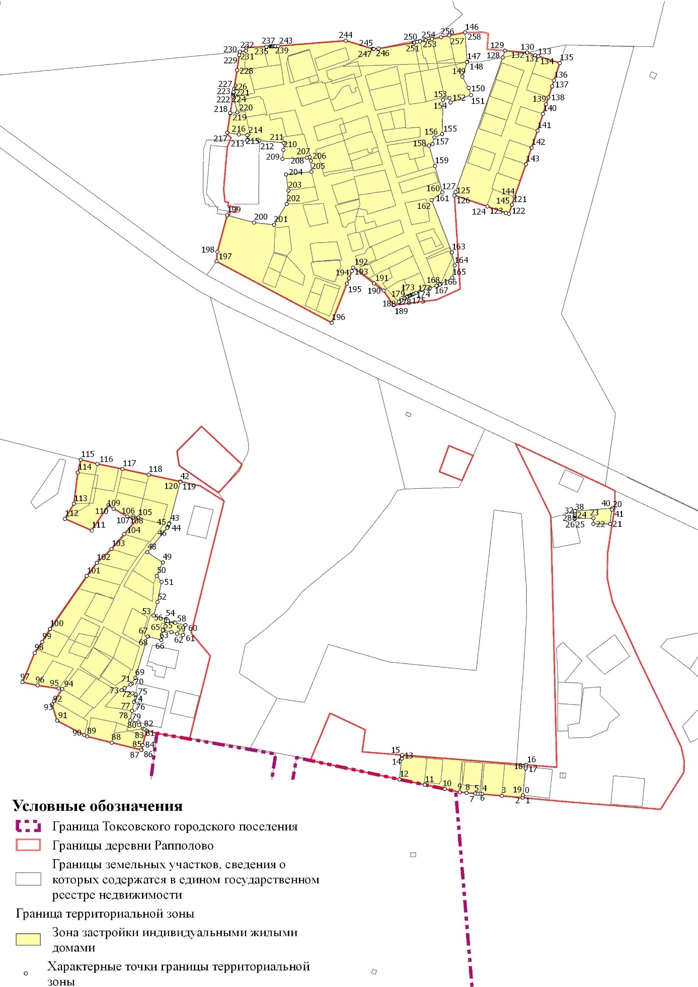
Ж-1-1. Подзона планируемой застройки индивидуальными жилыми домами

Ж-2. Зона застройки малоэтажными жилыми домами

ОД-1. Зона делового, общественного и коммерческого назначения
ОД-2. Зона размещения объектов социального и коммунально-бытового назначения учреждений
ИТ-1. Зона инженерной инфраструктуры
Р-1. Зона зеленых насаждений общего пользования
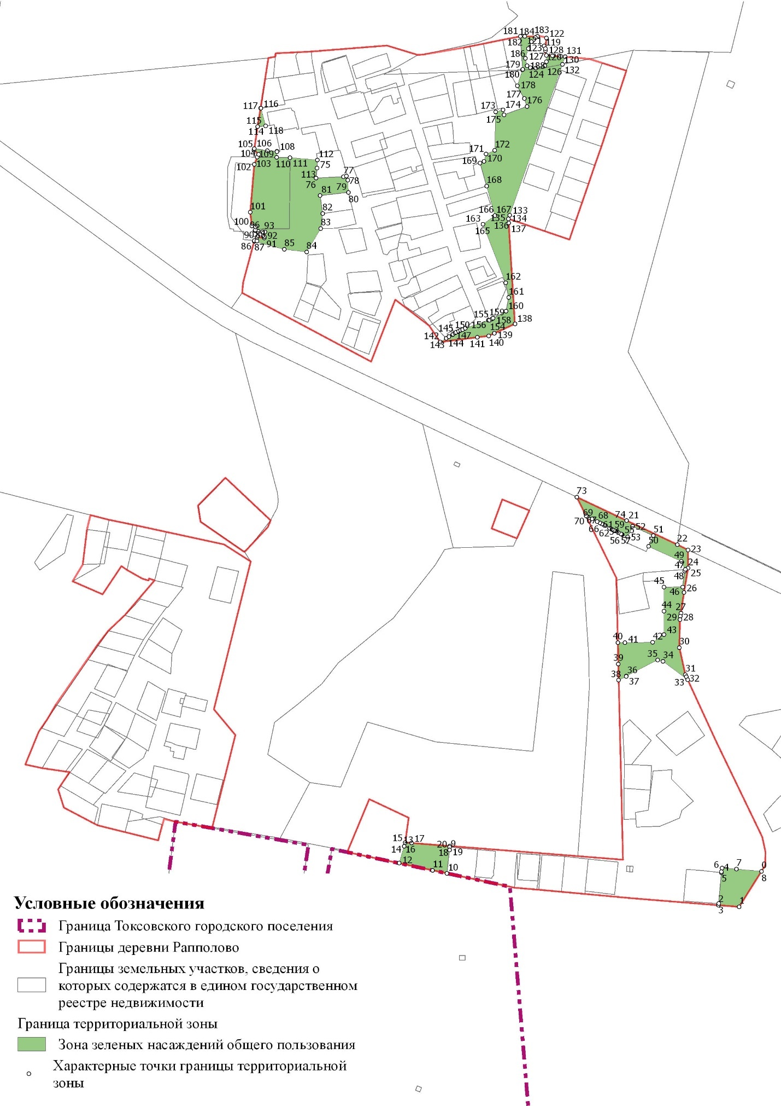

Перечень координат характерных точек границ территориальных зон
Ж-1. Зона застройки индивидуальными жилыми домами

N | Y | X
1 | 120544,82 | 118880,61
2 | 120544,58 | 118880,63
3 | 120509,14 | 118883,86
4 | 120475,94 | 118886,87
5 | 120471,83 | 118887,24
6 | 120468,03 | 118887,56
7 | 120464,18 | 118887,90
8 | 120449,29 | 118889,14
9 | 120437,85 | 118890,11
10 | 120412,37 | 118895,51
11 | 120378,23 | 118902,74
12 | 120335,06 | 118911,89
13 | 120338,80 | 118947,48
14 | 120339,25 | 118951,75
15 | 120339,33 | 118953,40
16 | 120550,23 | 118936,75
17 | 120550,01 | 118933,56
18 | 120549,73 | 118930,80
19 | 120545,12 | 118885,09
20 | 120696,65 | 119370,88
21 | 120693,40 | 119346,83
22 | 120665,30 | 119346,55
23 | 120665,03 | 119356,33
24 | 120633,31 | 119355,52
25 | 120633,30 | 119355,70
26 | 120633,30 | 119355,90
27 | 120633,29 | 119356,33
28 | 120633,29 | 119356,36
29 | 120633,28 | 119356,58
30 | 120633,38 | 119359,18
31 | 120633,38 | 119359,21
32 | 120633,44 | 119360,41
33 | 120633,47 | 119360,96
34 | 120633,48 | 119361,05
35 | 120633,49 | 119361,36
36 | 120633,57 | 119362,78
37 | 120633,57 | 119362,79
38 | 120633,75 | 119366,18
39 | 120633,87 | 119368,49
40 | 120697,48 | 119373,50
41 | 120696,65 | 119370,88
42 | 119962,00 | 119418,53
43 | 119943,13 | 119347,45
44 | 119942,88 | 119346,70
45 | 119940,70 | 119341,45
46 | 119940,35 | 119340,75
47 | 119939,80 | 119339,95
48 | 119905,83 | 119298,35
49 | 119932,00 | 119281,20
50 | 119922,10 | 119258,25
51 | 119929,93 | 119247,88
52 | 119923,05 | 119213,35
53 | 119916,65 | 119190,85
54 | 119937,70 | 119185,03
55 | 119938,55 | 119184,15
56 | 119937,10 | 119182,13
57 | 119940,70 | 119181,33
58 | 119952,13 | 119178,93
59 | 119953,35 | 119178,35
60 | 119970,88 | 119174,25
61 | 119966,85 | 119157,48
62 | 119956,65 | 119159,98
63 | 119946,70 | 119162,55
64 | 119933,55 | 119165,73
65 | 119932,18 | 119166,05
66 | 119929,40 | 119149,13
67 | 119906,50 | 119155,20
68 | 119906,45 | 119155,03
69 | 119885,33 | 119084,50
70 | 119879,13 | 119075,08
71 | 119877,30 | 119073,35
72 | 119867,33 | 119067,38
73 | 119861,88 | 119063,75
74 | 119880,23 | 119058,23
75 | 119885,67 | 119056,55
76 | 119883,20 | 119044,04
77 | 119879,95 | 119028,50
78 | 119876,55 | 119012,28
79 | 119890,87 | 119008,92
80 | 119891,93 | 119004,58
81 | 119898,55 | 118998,00
82 | 119901,22 | 118997,13
83 | 119904,65 | 118994,57
84 | 119897,83 | 118970,45
85 | 119895,82 | 118962,00
86 | 119895,47 | 118962,09
87 | 119895,45 | 118962,02
88 | 119845,21 | 118974,53
89 | 119803,49 | 118984,83
90 | 119798,61 | 118987,39
91 | 119752,23 | 119011,77
92 | 119743,50 | 119039,40
93 | 119747,12 | 119044,88
94 | 119760,98 | 119065,82
95 | 119754,65 | 119066,55
96 | 119719,20 | 119071,71
97 | 119693,60 | 119077,20
98 | 119714,00 | 119127,15
99 | 119726,94 | 119145,98
100 | 119740,01 | 119168,10
101 | 119802,65 | 119258,05
102 | 119819,87 | 119280,53
103 | 119844,79 | 119303,90
104 | 119866,48 | 119329,21
105 | 119890,43 | 119357,15
106 | 119881,79 | 119359,67
107 | 119880,87 | 119356,71
108 | 119871,55 | 119359,53
109 | 119848,20 | 119372,75
110 | 119839,75 | 119378,60
111 | 119811,08 | 119335,71
112 | 119765,47 | 119355,55
113 | 119780,95 | 119381,04
114 | 119787,38 | 119434,21
115 | 119792,70 | 119456,09
116 | 119820,98 | 119448,90
117 | 119863,61 | 119440,11
118 | 119908,12 | 119430,48
119 | 119962,05 | 119418,82
120 | 119962,00 | 119418,53
121 | 120526,65 | 119890,14
122 | 120521,41 | 119874,58
123 | 120516,58 | 119876,22
124 | 120484,82 | 119887,02
125 | 120428,60 | 119906,14
126 | 120428,60 | 119906,15
127 | 120430,58 | 119911,81
128 | 120510,70 | 120140,75
129 | 120514,69 | 120152,14
130 | 120551,83 | 120148,94
131 | 120551,89 | 120148,92
132 | 120552,58 | 120148,70
133 | 120566,17 | 120144,41
134 | 120571,24 | 120142,81
135 | 120607,97 | 120131,09
136 | 120598,34 | 120101,57
137 | 120594,94 | 120091,57
138 | 120588,55 | 120072,80
139 | 120584,63 | 120060,71
140 | 120579,39 | 120044,56
141 | 120570,07 | 120016,05
142 | 120559,97 | 119987,39
143 | 120550,34 | 119959,05
144 | 120531,02 | 119903,10
145 | 120526,65 | 119890,14
146 | 120446,60 | 120183,15
147 | 120450,18 | 120132,95
148 | 120449,98 | 120132,33
149 | 120442,05 | 120107,98
150 | 120452,60 | 120088,85
151 | 120456,83 | 120076,83
152 | 120421,68 | 120064,10
153 | 120420,43 | 120071,53
154 | 120409,08 | 120068,50
155 | 120407,73 | 120009,95
156 | 120394,63 | 120004,58
157 | 120391,28 | 119993,15
158 | 120385,38 | 119990,90
159 | 120395,35 | 119955,73
160 | 120408,13 | 119911,00
161 | 120408,12 | 119910,99
162 | 120389,80 | 119897,90
163 | 120424,28 | 119809,08
164 | 120428,83 | 119786,40
165 | 120424,95 | 119765,63
166 | 120405,15 | 119754,93
167 | 120403,59 | 119754,21
168 | 120399,33 | 119752,25
169 | 120398,23 | 119751,88
170 | 120398,22 | 119751,87
171 | 120386,80 | 119747,98
172 | 120362,85 | 119739,80
173 | 120362,86 | 119739,80
174 | 120359,06 | 119738,09
175 | 120355,96 | 119736,69
176 | 120353,58 | 119735,62
177 | 120352,62 | 119735,19
178 | 120351,31 | 119734,64
179 | 120349,01 | 119733,68
180 | 120348,74 | 119733,57
181 | 120348,53 | 119733,43
182 | 120347,28 | 119732,61
183 | 120347,24 | 119732,59
184 | 120344,07 | 119730,51
185 | 120343,53 | 119730,23
186 | 120343,52 | 119730,23
187 | 120337,84 | 119727,27
188 | 120333,76 | 119724,55
189 | 120324,74 | 119718,92
190 | 120307,99 | 119743,76
191 | 120291,74 | 119756,21
192 | 120256,43 | 119783,27
193 | 120253,91 | 119776,82
194 | 120249,14 | 119764,67
195 | 120245,59 | 119755,59
196 | 120219,59 | 119689,18
197 | 120023,42 | 119793,61
198 | 120025,03 | 119809,81
199 | 120041,77 | 119872,00
200 | 120087,70 | 119859,65
201 | 120121,53 | 119855,83
202 | 120143,10 | 119891,38
203 | 120145,80 | 119914,13
204 | 120142,18 | 119941,35
205 | 120185,20 | 119946,35
206 | 120184,00 | 119964,88
207 | 120182,04 | 119971,04
208 | 120177,58 | 119970,15
209 | 120135,90 | 119968,00
210 | 120137,52 | 119983,43
211 | 120137,90 | 119995,43
212 | 120096,48 | 119999,08
213 | 120075,87 | 119999,38
214 | 120076,58 | 120007,95
215 | 120076,31 | 120008,84
216 | 120061,53 | 120009,48
217 | 120041,98 | 120012,78
218 | 120046,98 | 120045,84
219 | 120047,00 | 120045,99
220 | 120059,13 | 120047,21
221 | 120052,10 | 120074,20
222 | 120051,43 | 120074,25
223 | 120052,05 | 120078,22
224 | 120052,28 | 120079,68
225 | 120052,40 | 120080,46
226 | 120052,57 | 120081,57
227 | 120053,50 | 120087,52
228 | 120058,42 | 120118,91
229 | 120062,44 | 120144,63
230 | 120063,34 | 120150,37
231 | 120073,91 | 120152,44
232 | 120073,91 | 120152,45
233 | 120074,37 | 120157,49
234 | 120108,44 | 120159,17
235 | 120115,05 | 120159,49
236 | 120116,43 | 120159,56
237 | 120117,65 | 120159,62
238 | 120117,83 | 120159,63
239 | 120118,99 | 120159,69
240 | 120120,73 | 120159,77
241 | 120122,70 | 120159,87
242 | 120124,26 | 120159,94
243 | 120128,52 | 120160,15
244 | 120243,68 | 120169,28
245 | 120289,71 | 120155,34
246 | 120290,80 | 120155,01
247 | 120290,98 | 120155,02
248 | 120291,10 | 120155,03
249 | 120299,28 | 120155,70
250 | 120359,47 | 120165,97
251 | 120360,30 | 120166,11
252 | 120364,95 | 120167,03
253 | 120370,25 | 120168,07
254 | 120379,60 | 120169,91
255 | 120390,52 | 120172,06
256 | 120405,37 | 120175,11
257 | 120419,91 | 120178,09
258 | 120446,60 | 120183,15

Ж-1-1. Подзона планируемой застройки индивидуальными жилыми домами

N | Y | X
1 | 119906,50 | 119155,20
2 | 119929,40 | 119149,13
3 | 119932,18 | 119166,05
4 | 119933,55 | 119165,73
5 | 119946,70 | 119162,55
6 | 119956,65 | 119159,98
7 | 119966,85 | 119157,48
8 | 119970,88 | 119174,25
9 | 119953,35 | 119178,35
10 | 119952,13 | 119178,93
11 | 119940,70 | 119181,33
12 | 119937,10 | 119182,13
13 | 119938,55 | 119184,15
14 | 119937,70 | 119185,03
15 | 119916,65 | 119190,85
16 | 119923,05 | 119213,35
17 | 119929,93 | 119247,88
18 | 119922,10 | 119258,25
19 | 119932,00 | 119281,20
20 | 119905,83 | 119298,35
21 | 119939,80 | 119339,95
22 | 119940,35 | 119340,75
23 | 119940,70 | 119341,45
24 | 119942,88 | 119346,70
25 | 119943,13 | 119347,45
26 | 119962,00 | 119418,53
27 | 119962,05 | 119418,82
28 | 119995,90 | 119411,50
29 | 120036,53 | 119385,60
30 | 119980,45 | 119161,10
31 | 120013,13 | 119121,98
32 | 119978,05 | 118982,10
33 | 119977,78 | 118980,60
34 | 119922,10 | 118990,33
35 | 119904,65 | 118994,57
36 | 119901,22 | 118997,13
37 | 119898,55 | 118998,00
38 | 119891,93 | 119004,58
39 | 119890,87 | 119008,92
40 | 119876,55 | 119012,28
41 | 119879,95 | 119028,50
42 | 119883,20 | 119044,04
43 | 119885,67 | 119056,55
44 | 119880,23 | 119058,23
45 | 119861,88 | 119063,75
46 | 119867,33 | 119067,38
47 | 119877,30 | 119073,35
48 | 119879,13 | 119075,08
49 | 119885,33 | 119084,50
50 | 119906,45 | 119155,03
51 | 119906,50 | 119155,20

Ж-2. Зона застройки малоэтажными жилыми домами

N | Y | X
1 | 120701,32 | 119205,94
2 | 120744,89 | 119111,60
3 | 120814,74 | 118967,06
4 | 120819,73 | 118943,87
5 | 120819,15 | 118923,91
6 | 120813,62 | 118915,13
7 | 120775,60 | 118918,30
8 | 120753,38 | 118920,15
9 | 120602,84 | 118932,59
10 | 120598,85 | 119100,80
11 | 120596,90 | 119182,58
12 | 120596,98 | 119179,43
13 | 120596,54 | 119197,44
14 | 120596,35 | 119205,28
15 | 120607,72 | 119210,95
16 | 120607,70 | 119211,43
17 | 120655,43 | 119236,15
18 | 120663,83 | 119233,80
19 | 120701,32 | 119205,94
20 | 120606,32 | 119414,97
21 | 120638,18 | 119400,83
22 | 120641,59 | 119408,41
23 | 120691,53 | 119385,83
24 | 120697,48 | 119373,50
25 | 120633,87 | 119368,49
26 | 120633,75 | 119366,18
27 | 120633,57 | 119362,79
28 | 120633,57 | 119362,78
29 | 120633,49 | 119361,36
30 | 120633,48 | 119361,05
31 | 120633,47 | 119360,96
32 | 120633,44 | 119360,41
33 | 120633,38 | 119359,21
34 | 120633,38 | 119359,18
35 | 120633,28 | 119356,58
36 | 120633,29 | 119356,36
37 | 120633,29 | 119356,33
38 | 120633,30 | 119355,90
39 | 120633,30 | 119355,70
40 | 120633,31 | 119355,67
41 | 120633,31 | 119355,52
42 | 120665,03 | 119356,33
43 | 120665,30 | 119346,55
44 | 120665,15 | 119310,05
45 | 120665,15 | 119274,78
46 | 120648,03 | 119262,68
47 | 120605,70 | 119262,45
48 | 120595,00 | 119262,48
49 | 120593,70 | 119316,83
50 | 120592,75 | 119356,81
51 | 120592,66 | 119360,89
52 | 120563,22 | 119420,92
53 | 120546,60 | 119454,80
54 | 120548,48 | 119454,03
55 | 120555,87 | 119450,17
56 | 120563,46 | 119446,22
57 | 120567,71 | 119444,00
58 | 120570,64 | 119442,47
59 | 120574,51 | 119440,46
60 | 120582,48 | 119436,30
61 | 120584,03 | 119435,49
62 | 120586,70 | 119434,10
63 | 120589,55 | 119432,61
64 | 120590,36 | 119432,19
65 | 120590,86 | 119431,93
66 | 120595,69 | 119429,41
67 | 120599,45 | 119427,45
68 | 120600,78 | 119426,85
69 | 120609,84 | 119422,76
70 | 120606,32 | 119414,97

ОД-1. Зона делового, общественного и коммерческого назначения

N | Y | X
1 | 120752,58 | 118912,90
2 | 120748,25 | 118865,90
3 | 120748,05 | 118863,49
4 | 120696,88 | 118867,61
5 | 120647,95 | 118871,55
6 | 120619,00 | 118873,88
7 | 120544,82 | 118880,61
8 | 120545,12 | 118885,09
9 | 120549,73 | 118930,80
10 | 120550,01 | 118933,56
11 | 120550,23 | 118936,75
12 | 120602,79 | 118932,60
13 | 120602,84 | 118932,59
14 | 120753,38 | 118920,15
15 | 120752,75 | 118914,35
16 | 120752,58 | 118912,90
17 | 120649,03 | 119424,83
18 | 120641,59 | 119408,41
19 | 120638,18 | 119400,83
20 | 120606,32 | 119414,97
21 | 120617,22 | 119439,10
22 | 120649,03 | 119424,83

ОД-2. Зона размещения объектов социального и коммунально-бытового назначения

N | Y | X
1 | 120460,39 | 119463,10
2 | 120441,43 | 119420,68
3 | 120403,03 | 119435,68
4 | 120411,61 | 119459,04
5 | 120419,23 | 119479,80
6 | 120448,51 | 119467,92
7 | 120460,39 | 119463,10
8 | 120028,91 | 119401,91
9 | 120027,00 | 119400,20
10 | 120024,68 | 119401,45
11 | 119960,15 | 119445,90
12 | 119956,35 | 119469,90
13 | 119956,82 | 119471,15
14 | 119998,05 | 119512,75
15 | 120066,70 | 119448,15
16 | 120066,80 | 119447,80
17 | 120066,17 | 119446,35
18 | 120065,12 | 119443,95
19 | 120064,83 | 119443,30
20 | 120064,46 | 119442,43
21 | 120062,50 | 119437,95
22 | 120028,91 | 119401,91

Р-1. Зона зеленых насаждений общего пользования

N | Y | X
1 | 120779,52 | 118860,96
2 | 120748,05 | 118863,49
3 | 120748,25 | 118865,90
4 | 120752,58 | 118912,90
5 | 120752,75 | 118914,35
6 | 120753,38 | 118920,15
7 | 120775,60 | 118918,30
8 | 120813,62 | 118915,13
9 | 120338,80 | 118947,48
10 | 120335,06 | 118911,89
11 | 120313,38 | 118916,49
12 | 120262,25 | 118927,34
13 | 120269,85 | 118953,18
14 | 120269,86 | 118953,18
15 | 120271,49 | 118958,80
16 | 120271,50 | 118958,80
17 | 120281,16 | 118958,04
18 | 120339,33 | 118953,43
19 | 120339,25 | 118951,75
20 | 120338,80 | 118947,48
21 | 120608,18 | 119447,80
22 | 120685,49 | 119411,35
23 | 120701,85 | 119403,17
24 | 120701,85 | 119375,43
25 | 120701,85 | 119375,42
26 | 120695,73 | 119338,58
27 | 120690,92 | 119307,27
28 | 120690,19 | 119302,51
29 | 120689,42 | 119297,52
30 | 120688,75 | 119254,60
31 | 120697,75 | 119213,65
32 | 120699,27 | 119210,36
33 | 120701,32 | 119205,94
34 | 120663,83 | 119233,80
35 | 120655,43 | 119236,15
36 | 120607,71 | 119211,44
37 | 120607,73 | 119210,95
38 | 120596,35 | 119205,28
39 | 120595,77 | 119229,80
40 | 120595,00 | 119262,48
41 | 120605,70 | 119262,45
42 | 120648,03 | 119262,68
43 | 120665,15 | 119274,78
44 | 120665,15 | 119310,05
45 | 120665,30 | 119346,55
46 | 120693,40 | 119346,83
47 | 120696,65 | 119370,88
48 | 120697,48 | 119373,50
49 | 120691,53 | 119385,83
50 | 120641,59 | 119408,41
51 | 120649,03 | 119424,83
52 | 120617,22 | 119439,10
53 | 120609,85 | 119422,75
54 | 120601,77 | 119426,40
55 | 120600,78 | 119426,85
56 | 120599,78 | 119427,30
57 | 120599,45 | 119427,45
58 | 120595,69 | 119429,41
59 | 120590,86 | 119431,93
60 | 120590,36 | 119432,19
61 | 120589,55 | 119432,61
62 | 120586,70 | 119434,10
63 | 120584,03 | 119435,49
64 | 120582,48 | 119436,30
65 | 120574,51 | 119440,46
66 | 120570,64 | 119442,47
67 | 120567,71 | 119444,00
68 | 120563,46 | 119446,22
69 | 120555,87 | 119450,17
70 | 120548,48 | 119454,03
71 | 120548,41 | 119454,06
72 | 120546,60 | 119454,80
73 | 120532,55 | 119483,45
74 | 120608,18 | 119447,80
75 | 120137,52 | 119983,43
76 | 120135,90 | 119968,00
77 | 120177,58 | 119970,15
78 | 120182,04 | 119971,04
79 | 120184,00 | 119964,93
80 | 120185,20 | 119946,35
81 | 120142,18 | 119941,35
82 | 120145,80 | 119914,13
83 | 120143,10 | 119891,38
84 | 120121,53 | 119855,83
85 | 120087,70 | 119859,65
86 | 120041,77 | 119872,00
87 | 120042,06 | 119873,07
88 | 120045,99 | 119872,70
89 | 120046,00 | 119872,70
90 | 120046,53 | 119878,70
91 | 120056,90 | 119877,07
92 | 120057,22 | 119879,18
93 | 120058,33 | 119886,40
94 | 120054,83 | 119886,13
95 | 120054,12 | 119886,08
96 | 120047,30 | 119887,28
97 | 120043,03 | 119888,02
98 | 120043,22 | 119889,22
99 | 120043,97 | 119893,80
100 | 120038,10 | 119895,14
101 | 120035,76 | 119915,98
102 | 120041,90 | 119988,63
103 | 120046,67 | 119999,81
104 | 120048,48 | 120004,05
105 | 120041,60 | 120010,28
106 | 120041,98 | 120012,78
107 | 120061,53 | 120009,48
108 | 120076,31 | 120008,84
109 | 120076,58 | 120007,95
110 | 120075,87 | 119999,38
111 | 120096,47 | 119999,08
112 | 120137,90 | 119995,43
113 | 120137,52 | 119983,43
114 | 120059,13 | 120047,21
115 | 120047,00 | 120045,99
116 | 120051,43 | 120074,25
117 | 120052,10 | 120074,20
118 | 120059,13 | 120047,21
119 | 120485,02 | 120164,73
120 | 120484,75 | 120161,55
121 | 120482,93 | 120168,63
122 | 120486,31 | 120180,63
123 | 120485,02 | 120164,73
124 | 120462,00 | 120135,43
125 | 120470,23 | 120135,00
126 | 120483,65 | 120138,55
127 | 120486,20 | 120144,75
128 | 120486,25 | 120154,58
129 | 120495,52 | 120153,79
130 | 120508,10 | 120152,68
131 | 120514,69 | 120152,14
132 | 120510,70 | 120140,75
133 | 120430,58 | 119911,81
134 | 120428,60 | 119906,15
135 | 120428,60 | 119906,14
136 | 120428,59 | 119906,14
137 | 120428,99 | 119899,68
138 | 120438,39 | 119746,46
139 | 120407,03 | 119732,13
140 | 120398,65 | 119728,30
141 | 120381,02 | 119726,06
142 | 120324,74 | 119718,92
143 | 120333,76 | 119724,55
144 | 120337,84 | 119727,27
145 | 120343,52 | 119730,23
146 | 120343,53 | 119730,23
147 | 120344,07 | 119730,51
148 | 120347,24 | 119732,59
149 | 120348,74 | 119733,57
150 | 120352,62 | 119735,19
151 | 120355,96 | 119736,69
152 | 120359,06 | 119738,09
153 | 120362,86 | 119739,80
154 | 120398,22 | 119751,87
155 | 120398,23 | 119751,88
156 | 120399,33 | 119752,25
157 | 120403,59 | 119754,21
158 | 120405,14 | 119754,93
159 | 120405,15 | 119754,93
160 | 120424,96 | 119765,62
161 | 120428,83 | 119786,40
162 | 120424,28 | 119809,08
163 | 120389,80 | 119897,89
164 | 120389,79 | 119897,89
165 | 120389,80 | 119897,90
166 | 120408,12 | 119910,99
167 | 120408,13 | 119911,00
168 | 120395,35 | 119955,73
169 | 120385,38 | 119990,90
170 | 120391,28 | 119993,15
171 | 120394,63 | 120004,58
172 | 120407,73 | 120009,95
173 | 120409,08 | 120068,50
174 | 120420,43 | 120071,53
175 | 120421,68 | 120064,10
176 | 120456,83 | 120076,83
177 | 120452,60 | 120088,85
178 | 120442,05 | 120107,98
179 | 120449,98 | 120132,33
180 | 120450,18 | 120132,95
181 | 120446,61 | 120183,16
182 | 120453,39 | 120183,25
183 | 120472,54 | 120183,52
184 | 120469,80 | 120181,25
185 | 120463,75 | 120175,20
186 | 120458,70 | 120164,60
187 | 120454,18 | 120149,80
188 | 120456,68 | 120138,85
189 | 120462,00 | 120135,43

ИТ-1. Зона инженерной инфраструктуры

N | Y | X
1 | 120269,85 | 118953,15
2 | 120262,25 | 118927,34
3 | 120185,23 | 118943,69
4 | 120184,56 | 118947,15
5 | 120212,84 | 119014,95
6 | 120216,87 | 119024,59
7 | 120258,90 | 119004,77
8 | 120276,82 | 118996,31
9 | 120271,49 | 118958,80
10 | 120269,85 | 118953,15

