Правила землепользования и застройки
муниципального образования
Токсовское городское поселение
Всеволожского муниципального района
ленинградской области

Приложение
Сведения о границах территориальных зон

Санкт-Петербург – Токсово
2018

Деревня Кавголово

Графическое описание местоположения границ территориальных зон
Ж-1. Зона застройки индивидуальными жилыми домами
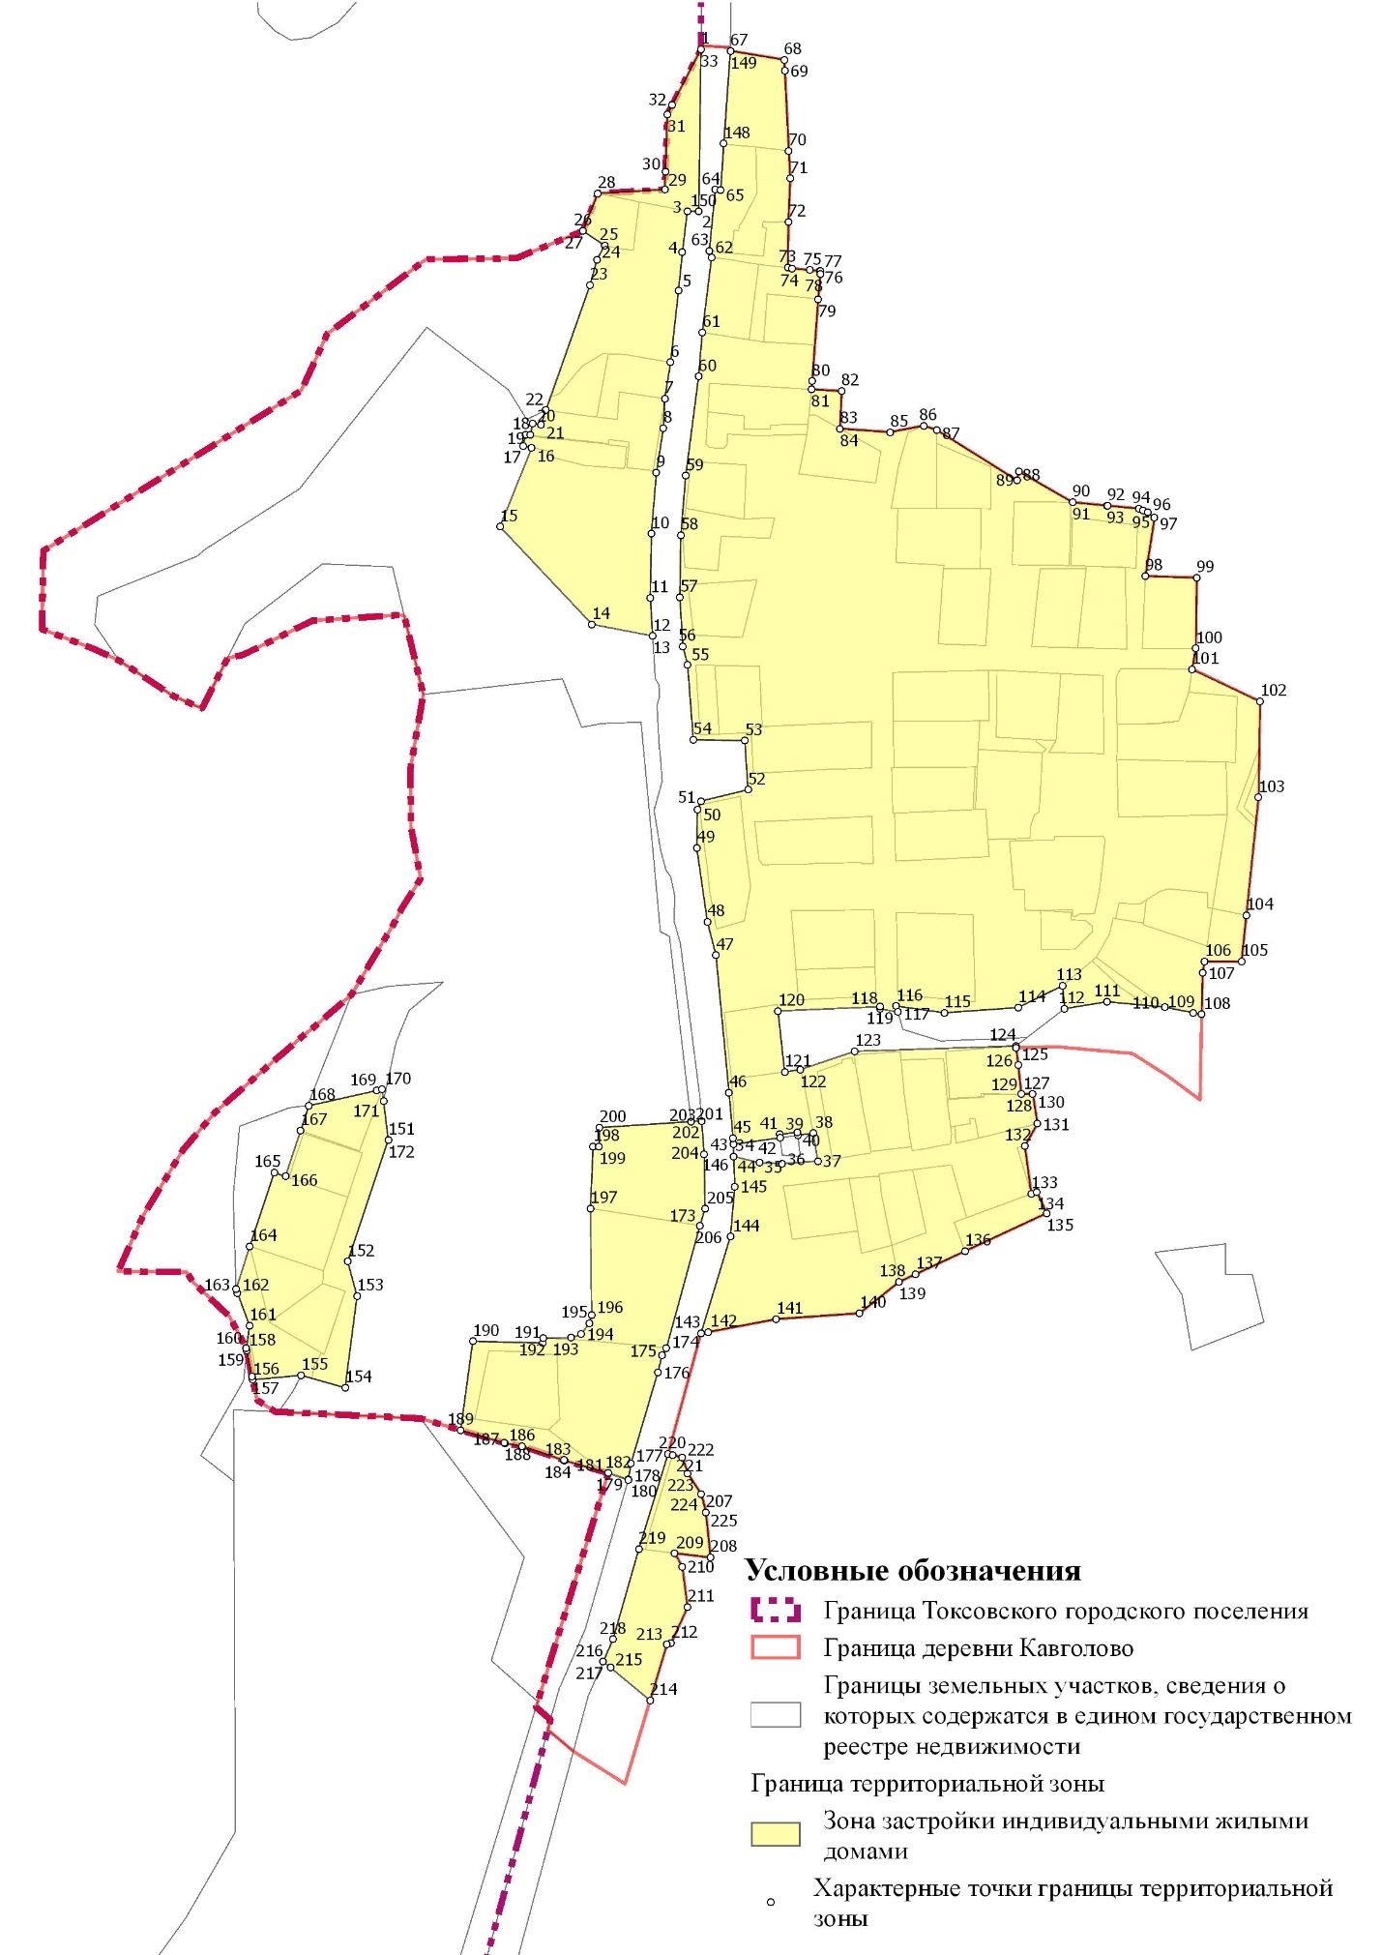
ОД-1. Зона делового, общественного и коммерческого назначения

Р-1. Зона зеленых насаждений общего пользования
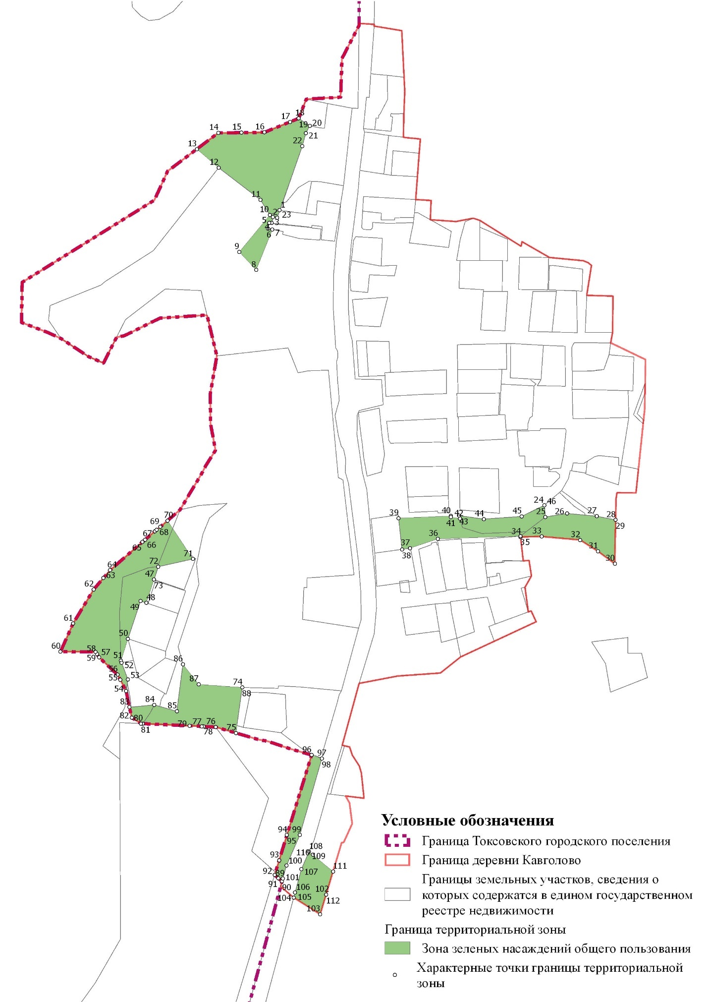

ИТ-2. Зона транспортной инфраструктуры
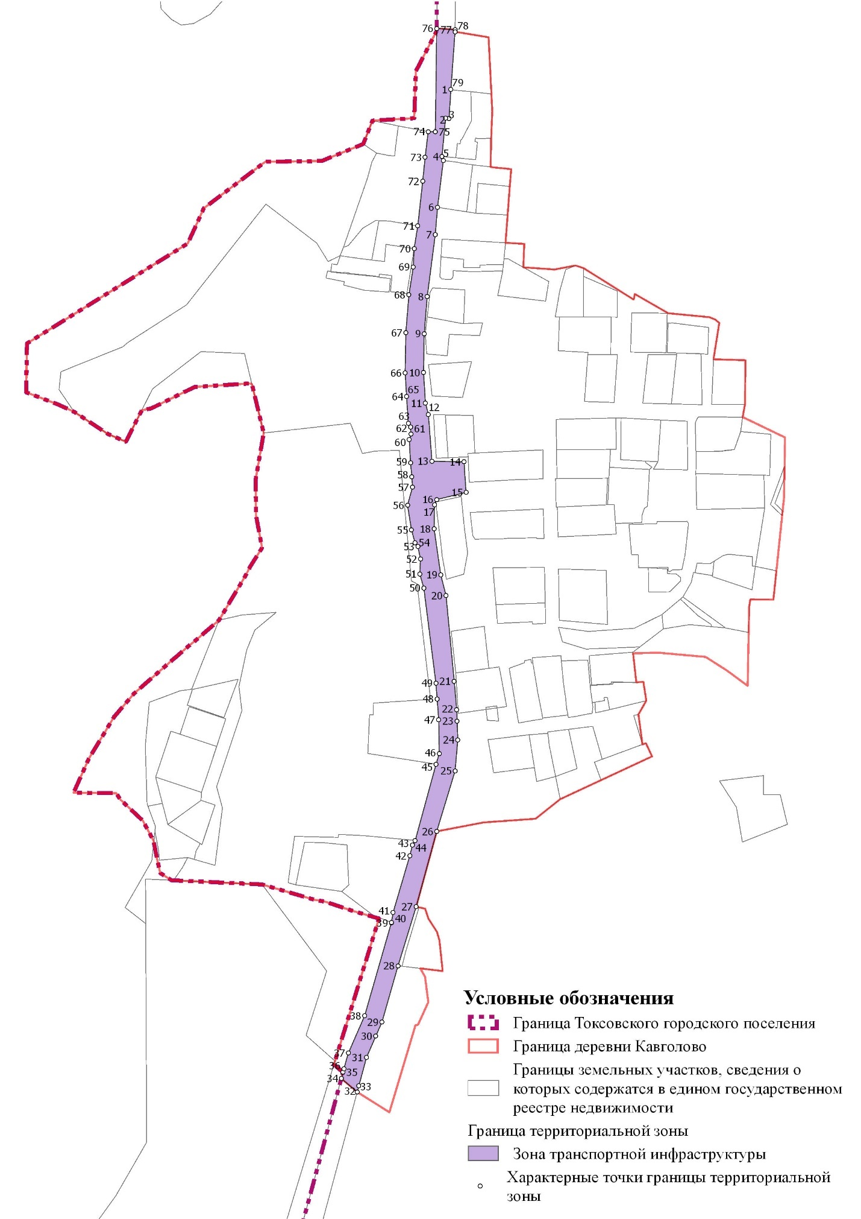

СХ-1. Зона сельскохозяйственного производства
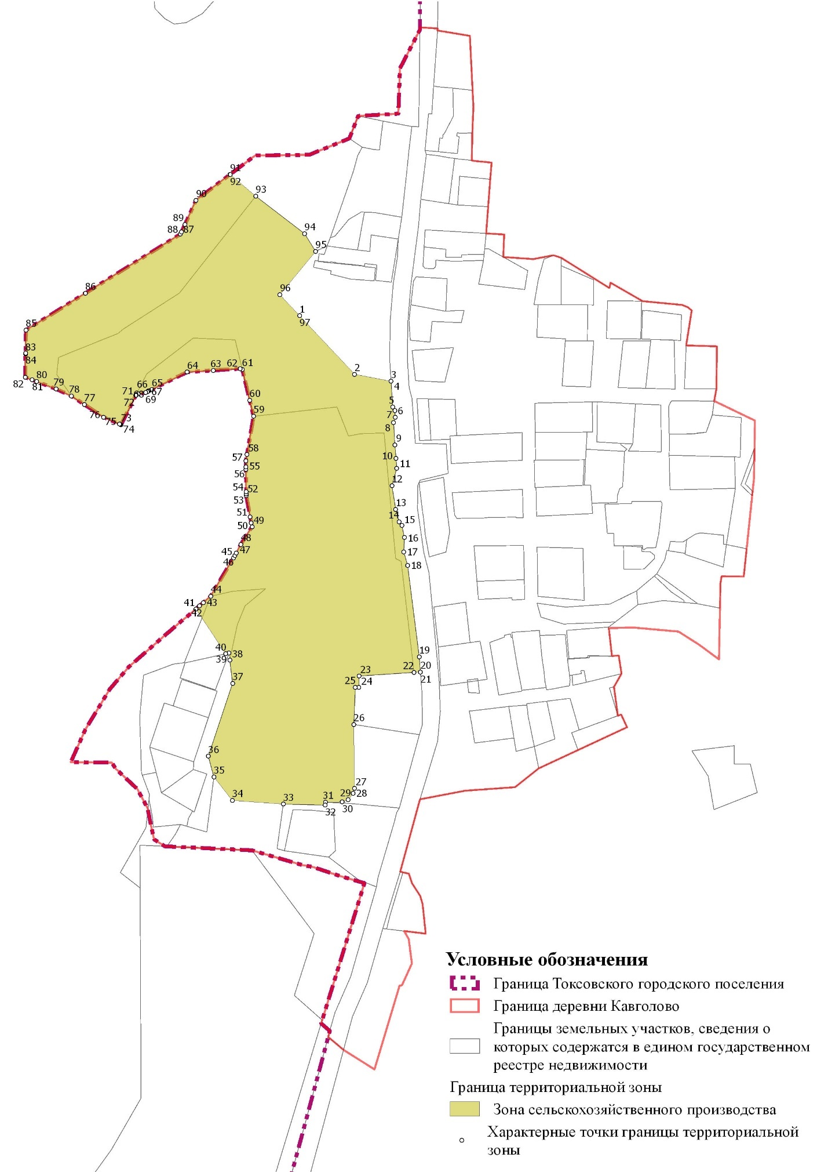

Перечень координат характерных точек границ территориальных зон

Ж-1. Зона застройки индивидуальными жилыми домами

N | Y | X
1 | 119771,04 | 122226,73
2 | 119769,68 | 122122,33
3 | 119762,26 | 122122,54
4 | 119759,10 | 122096,04
5 | 119756,57 | 122071,24
6 | 119751,48 | 122025,06
7 | 119747,70 | 122001,64
8 | 119746,84 | 121982,61
9 | 119742,32 | 121953,92
10 | 119739,08 | 121914,61
11 | 119738,42 | 121873,11
12 | 119739,92 | 121848,70
13 | 119739,90 | 121848,75
14 | 119700,80 | 121856,25
15 | 119641,43 | 121919,15
16 | 119661,95 | 121969,98
17 | 119656,38 | 121971,25
18 | 119658,13 | 121978,50
19 | 119661,05 | 121978,35
20 | 119662,53 | 121985,75
21 | 119668,03 | 121984,98
22 | 119670,99 | 121994,28
23 | 119699,50 | 122074,75
24 | 119703,95 | 122091,08
25 | 119708,84 | 122100,38
26 | 119695,01 | 122109,72
27 | 119695,01 | 122109,73
28 | 119704,58 | 122133,93
29 | 119747,80 | 122136,40
30 | 119748,19 | 122147,85
31 | 119749,45 | 122184,93
32 | 119752,49 | 122190,81
33 | 119771,04 | 122226,73
34 | 119792,20 | 121513,33
35 | 119808,65 | 121509,23
36 | 119823,20 | 121508,60
37 | 119846,40 | 121510,25
38 | 119843,40 | 121528,30
39 | 119833,45 | 121526,91
40 | 119833,20 | 121528,90
41 | 119821,80 | 121527,45
42 | 119822,07 | 121525,32
43 | 119791,95 | 121521,08
44 | 119792,20 | 121513,33
45 | 119791,79 | 121525,11
46 | 119789,16 | 121554,45
47 | 119780,73 | 121642,95
48 | 119775,19 | 121664,57
49 | 119768,38 | 121711,97
50 | 119768,74 | 121736,67
51 | 119771,21 | 121742,33
52 | 119801,42 | 121749,63
53 | 119799,31 | 121781,21
54 | 119766,12 | 121781,92
55 | 119762,44 | 121830,30
56 | 119759,41 | 121841,90
57 | 119757,43 | 121873,55
58 | 119758,07 | 121913,67
59 | 119761,22 | 121951,92
60 | 119769,54 | 122015,92
61 | 119771,92 | 122044,44
62 | 119777,92 | 122092,70
63 | 119776,47 | 122096,87
64 | 119780,28 | 122136,36
65 | 119783,82 | 122136,15
66 | 119783,83 | 122136,15
67 | 119790,03 | 122225,77
68 | 119824,75 | 122220,05
69 | 119825,10 | 122213,05
70 | 119827,68 | 122161,43
71 | 119828,57 | 122143,54
72 | 119827,40 | 122115,70
73 | 119826,93 | 122086,15
74 | 119829,95 | 122085,52
75 | 119841,18 | 122084,50
76 | 119847,53 | 122083,80
77 | 119848,15 | 122083,73
78 | 119848,03 | 122082,11
79 | 119846,65 | 122065,69
80 | 119842,70 | 122012,87
81 | 119842,30 | 122007,65
82 | 119861,68 | 122006,50
83 | 119860,70 | 121982,29
84 | 119860,70 | 121982,28
85 | 119893,03 | 121980,04
86 | 119914,68 | 121984,20
87 | 119923,10 | 121981,42
88 | 119974,90 | 121948,92
89 | 119976,15 | 121954,65
90 | 120010,65 | 121934,83
91 | 120010,66 | 121934,83
92 | 120032,88 | 121932,70
93 | 120033,05 | 121932,68
94 | 120053,30 | 121930,75
95 | 120055,91 | 121929,69
96 | 120059,25 | 121928,32
97 | 120063,52 | 121924,87
98 | 120057,55 | 121887,25
99 | 120090,67 | 121886,22
100 | 120090,15 | 121840,65
101 | 120087,65 | 121827,18
102 | 120131,58 | 121806,43
103 | 120130,57 | 121744,63
104 | 120122,65 | 121668,61
105 | 120119,55 | 121638,88
106 | 120095,73 | 121639,00
107 | 120094,48 | 121631,60
108 | 120093,95 | 121604,85
109 | 120088,67 | 121605,88
110 | 120070,05 | 121609,53
111 | 120032,88 | 121612,98
112 | 120005,60 | 121608,55
113 | 120004,23 | 121623,38
114 | 119975,65 | 121609,23
115 | 119927,90 | 121605,90
116 | 119897,02 | 121610,18
117 | 119898,11 | 121606,33
118 | 119886,48 | 121608,38
119 | 119886,38 | 121609,80
120 | 119820,70 | 121607,03
121 | 119825,03 | 121567,80
122 | 119834,97 | 121569,18
123 | 119870,34 | 121581,02
124 | 119974,18 | 121584,48
125 | 119974,30 | 121583,32
126 | 119975,55 | 121572,20
127 | 119977,65 | 121553,40
128 | 119977,66 | 121553,40
129 | 119977,66 | 121553,39
130 | 119984,98 | 121553,72
131 | 119987,98 | 121534,37
132 | 119979,85 | 121520,13
133 | 119984,04 | 121489,14
134 | 119987,57 | 121490,42
135 | 119993,92 | 121476,77
136 | 119941,23 | 121452,26
137 | 119909,42 | 121437,46
138 | 119898,88 | 121432,55
139 | 119898,67 | 121432,39
140 | 119873,38 | 121412,32
141 | 119819,65 | 121408,52
142 | 119775,80 | 121400,17
143 | 119771,08 | 121399,27
144 | 119790,06 | 121461,78
145 | 119792,88 | 121493,83
146 | 119792,20 | 121513,33
147 | 119783,82 | 122136,15
148 | 119785,73 | 122166,02
149 | 119790,02 | 122225,77
150 | 119783,82 | 122136,15
151 | 119569,41 | 121524,02
152 | 119543,25 | 121445,56
153 | 119549,28 | 121423,34
154 | 119541,60 | 121364,18
155 | 119513,30 | 121372,25
156 | 119481,94 | 121369,36
157 | 119481,50 | 121371,30
158 | 119478,20 | 121388,25
159 | 119477,90 | 121389,77
160 | 119477,90 | 121389,78
161 | 119479,93 | 121404,38
162 | 119472,17 | 121425,34
163 | 119471,30 | 121427,70
164 | 119480,12 | 121455,37
165 | 119495,88 | 121502,83
166 | 119503,13 | 121500,41
167 | 119512,92 | 121529,83
168 | 119518,25 | 121545,97
169 | 119561,93 | 121555,71
170 | 119565,55 | 121556,52
171 | 119566,37 | 121548,98
172 | 119569,41 | 121524,02
173 | 119770,42 | 121468,77
174 | 119748,82 | 121389,89
175 | 119746,03 | 121385,15
176 | 119743,20 | 121374,05
177 | 119725,92 | 121315,37
178 | 119724,23 | 121305,16
179 | 119724,10 | 121304,72
180 | 119724,10 | 121304,73
181 | 119711,27 | 121309,18
182 | 119711,24 | 121309,18
183 | 119683,16 | 121317,36
184 | 119682,84 | 121317,49
185 | 119682,68 | 121317,55
186 | 119655,60 | 121326,60
187 | 119644,74 | 121328,55
188 | 119644,20 | 121328,71
189 | 119616,13 | 121336,89
190 | 119623,90 | 121394,15
191 | 119669,13 | 121393,05
192 | 119669,50 | 121396,20
193 | 119687,48 | 121396,43
194 | 119693,85 | 121398,78
195 | 119699,23 | 121405,83
196 | 119700,58 | 121411,20
197 | 119699,80 | 121479,80
198 | 119701,53 | 121519,65
199 | 119705,38 | 121519,80
200 | 119705,60 | 121531,85
201 | 119764,67 | 121535,70
202 | 119771,50 | 121536,15
203 | 119771,51 | 121536,15
204 | 119773,16 | 121514,70
205 | 119773,68 | 121479,59
206 | 119770,42 | 121468,77
207 | 119774,17 | 121283,97
208 | 119777,20 | 121254,90
209 | 119754,05 | 121257,65
210 | 119759,00 | 121248,92
211 | 119762,35 | 121222,78
212 | 119751,77 | 121199,55
213 | 119749,10 | 121198,95
214 | 119738,23 | 121162,70
215 | 119712,65 | 121183,93
216 | 119708,03 | 121187,63
217 | 119708,03 | 121187,63
218 | 119714,36 | 121202,12
219 | 119731,02 | 121260,31
220 | 119749,83 | 121321,53
221 | 119752,75 | 121320,73
222 | 119759,08 | 121319,39
223 | 119762,52 | 121308,99
224 | 119771,30 | 121295,43
225 | 119774,17 | 121283,97

ОД-1. Зона делового, общественного и коммерческого назначения

N | Y | X
1 | 119833,20 | 121528,90
2 | 119833,45 | 121526,91
3 | 119843,40 | 121528,30
4 | 119846,40 | 121510,25
5 | 119823,20 | 121508,60
6 | 119808,65 | 121509,23
7 | 119792,20 | 121513,33
8 | 119791,95 | 121521,08
9 | 119822,07 | 121525,32
10 | 119821,80 | 121527,45
11 | 119833,20 | 121528,90

Р-1. Зона зеленых насаждений общего пользования

N | Y | X
1 | 119670,99 | 121994,28
2 | 119668,03 | 121984,98
3 | 119662,53 | 121985,75
4 | 119661,05 | 121978,35
5 | 119658,13 | 121978,50
6 | 119656,38 | 121971,25
7 | 119661,95 | 121969,98
8 | 119641,43 | 121919,15
9 | 119620,28 | 121941,80
10 | 119658,70 | 121988,28
11 | 119646,88 | 122007,33
12 | 119594,28 | 122047,65
13 | 119566,85 | 122071,05
14 | 119593,92 | 122091,43
15 | 119622,88 | 122091,81
16 | 119651,95 | 122092,20
17 | 119684,11 | 122105,29
18 | 119695,00 | 122109,73
19 | 119695,00 | 122109,73
20 | 119708,84 | 122100,38
21 | 119703,95 | 122091,08
22 | 119699,50 | 122074,75
23 | 119670,99 | 121994,28
24 | 120004,23 | 121623,38
25 | 120005,60 | 121608,55
26 | 120032,88 | 121612,98
27 | 120070,05 | 121609,53
28 | 120093,95 | 121604,85
29 | 120093,96 | 121604,82
30 | 120092,88 | 121549,72
31 | 120071,55 | 121565,47
32 | 120049,35 | 121579,60
33 | 120000,75 | 121583,95
34 | 119974,30 | 121583,32
35 | 119974,18 | 121584,48
36 | 119870,34 | 121581,02
37 | 119834,97 | 121569,18
38 | 119825,03 | 121567,80
39 | 119820,70 | 121607,03
40 | 119886,38 | 121609,80
41 | 119886,48 | 121608,38
42 | 119898,11 | 121606,33
43 | 119897,02 | 121610,18
44 | 119927,90 | 121605,90
45 | 119975,65 | 121609,23
46 | 120004,23 | 121623,38
47 | 119512,92 | 121529,83
48 | 119503,13 | 121500,41
49 | 119495,88 | 121502,83
50 | 119480,12 | 121455,37
51 | 119471,30 | 121427,70
52 | 119472,17 | 121425,34
53 | 119479,93 | 121404,38
54 | 119477,90 | 121389,78
55 | 119470,47 | 121403,68
56 | 119466,97 | 121410,20
57 | 119443,70 | 121432,08
58 | 119441,10 | 121436,10
59 | 119439,40 | 121438,73
60 | 119395,23 | 121439,20
61 | 119411,04 | 121474,53
62 | 119437,05 | 121517,50
63 | 119449,27 | 121531,81
64 | 119457,63 | 121541,60
65 | 119498,30 | 121577,15
66 | 119501,68 | 121579,91
67 | 119514,02 | 121590,65
68 | 119516,12 | 121592,32
69 | 119520,91 | 121596,16
70 | 119529,88 | 121603,90
71 | 119561,93 | 121555,71
72 | 119518,25 | 121545,97
73 | 119512,92 | 121529,83
74 | 119623,90 | 121394,15
75 | 119616,13 | 121336,89
76 | 119590,35 | 121344,40
77 | 119575,26 | 121345,10
78 | 119572,92 | 121345,21
79 | 119557,92 | 121345,90
80 | 119498,65 | 121348,66
81 | 119496,47 | 121348,76
82 | 119484,93 | 121356,20
83 | 119481,94 | 121369,36
84 | 119513,30 | 121372,25
85 | 119541,60 | 121364,18
86 | 119549,28 | 121423,34
87 | 119569,08 | 121398,03
88 | 119623,90 | 121394,15
89 | 119674,94 | 121153,72
90 | 119674,02 | 121150,28
91 | 119669,38 | 121154,30
92 | 119664,73 | 121158,33
93 | 119670,39 | 121176,66
94 | 119680,22 | 121208,53
95 | 119680,23 | 121208,55
96 | 119711,27 | 121309,17
97 | 119724,10 | 121304,73
98 | 119724,10 | 121304,72
99 | 119696,44 | 121208,57
100 | 119679,61 | 121170,09
101 | 119674,94 | 121153,72
102 | 119729,52 | 121133,68
103 | 119722,10 | 121108,95
104 | 119688,80 | 121129,90
105 | 119690,48 | 121136,18
106 | 119690,48 | 121136,18
107 | 119698,35 | 121165,50
108 | 119708,03 | 121187,63
109 | 119708,03 | 121187,63
110 | 119712,65 | 121183,93
111 | 119738,23 | 121162,70
112 | 119729,52 | 121133,68

СХ-1. Зона сельскохозяйственного производства

N | Y | X
1 | 119641,43 | 121919,15
2 | 119700,80 | 121856,25
3 | 119739,92 | 121848,70
4 | 119739,92 | 121848,69
5 | 119741,61 | 121821,08
6 | 119743,94 | 121817,37
7 | 119744,45 | 121809,99
8 | 119742,72 | 121804,13
9 | 119743,95 | 121780,31
10 | 119745,35 | 121765,94
11 | 119746,01 | 121755,01
12 | 119740,84 | 121736,34
13 | 119745,00 | 121710,79
14 | 119748,58 | 121697,61
15 | 119751,54 | 121693,60
16 | 119754,29 | 121680,75
17 | 119753,57 | 121665,36
18 | 119757,72 | 121650,78
19 | 119770,25 | 121552,51
20 | 119771,51 | 121536,15
21 | 119771,50 | 121536,15
22 | 119764,67 | 121535,76
23 | 119705,60 | 121531,85
24 | 119705,38 | 121519,80
25 | 119701,53 | 121519,65
26 | 119699,80 | 121479,80
27 | 119700,58 | 121411,20
28 | 119699,23 | 121405,83
29 | 119693,85 | 121398,78
30 | 119687,48 | 121396,43
31 | 119669,50 | 121396,20
32 | 119669,13 | 121393,05
33 | 119623,90 | 121394,15
34 | 119569,08 | 121398,03
35 | 119549,28 | 121423,34
36 | 119543,25 | 121445,56
37 | 119569,41 | 121524,02
38 | 119566,37 | 121548,98
39 | 119565,55 | 121556,52
40 | 119561,93 | 121555,71
41 | 119529,88 | 121603,90
42 | 119533,59 | 121607,09
43 | 119537,94 | 121610,85
44 | 119545,75 | 121617,58
45 | 119570,23 | 121658,65
46 | 119571,94 | 121661,52
47 | 119573,42 | 121664,00
48 | 119578,15 | 121673,20
49 | 119590,33 | 121692,37
50 | 119589,55 | 121696,50
51 | 119588,34 | 121702,98
52 | 119584,05 | 121725,85
53 | 119584,03 | 121727,71
54 | 119584,01 | 121729,85
55 | 119583,77 | 121753,83
56 | 119583,74 | 121756,55
57 | 119583,68 | 121763,15
58 | 119584,85 | 121769,92
59 | 119592,01 | 121811,03
60 | 119587,83 | 121828,27
61 | 119579,81 | 121861,44
62 | 119577,37 | 121862,25
63 | 119548,59 | 121860,41
64 | 119520,43 | 121858,60
65 | 119482,32 | 121839,77
66 | 119479,44 | 121838,35
67 | 119478,68 | 121837,97
68 | 119477,82 | 121837,55
69 | 119475,65 | 121836,48
70 | 119467,68 | 121834,95
71 | 119465,74 | 121834,47
72 | 119465,20 | 121833,41
73 | 119449,34 | 121802,06
74 | 119448,52 | 121802,41
75 | 119447,70 | 121802,76
76 | 119430,58 | 121810,10
77 | 119409,90 | 121823,66
78 | 119395,85 | 121832,88
79 | 119379,30 | 121840,48
80 | 119358,34 | 121848,46
81 | 119353,59 | 121850,27
82 | 119346,15 | 121853,10
83 | 119346,55 | 121878,35
84 | 119346,56 | 121878,74
85 | 119346,95 | 121903,60
86 | 119410,98 | 121943,35
87 | 119513,20 | 122006,82
88 | 119514,40 | 122009,36
89 | 119518,18 | 122017,35
90 | 119530,00 | 122043,30
91 | 119566,54 | 122070,91
92 | 119566,85 | 122071,05
93 | 119594,28 | 122047,65
94 | 119646,88 | 122007,33
95 | 119658,70 | 121988,28
96 | 119620,28 | 121941,80
97 | 119641,43 | 121919,15

ИТ-2. Зона транспортной инфраструктуры

N | Y | X
1 | 119785,73 | 122166,02
2 | 119783,82 | 122136,15
3 | 119780,28 | 122136,36
4 | 119776,47 | 122096,87
5 | 119777,92 | 122092,70
6 | 119771,92 | 122044,44
7 | 119769,54 | 122015,92
8 | 119761,22 | 121951,92
9 | 119758,07 | 121913,67
10 | 119757,43 | 121873,55
11 | 119759,41 | 121841,90
12 | 119762,44 | 121830,30
13 | 119766,12 | 121781,92
14 | 119799,31 | 121781,21
15 | 119801,42 | 121749,63
16 | 119771,21 | 121742,33
17 | 119768,74 | 121736,67
18 | 119768,38 | 121711,97
19 | 119775,19 | 121664,57
20 | 119780,73 | 121642,95
21 | 119789,16 | 121554,45
22 | 119791,79 | 121525,11
23 | 119792,20 | 121513,33
24 | 119792,88 | 121493,83
25 | 119790,06 | 121461,78
26 | 119771,08 | 121399,27
27 | 119749,83 | 121321,53
28 | 119731,02 | 121260,31
29 | 119714,36 | 121202,12
30 | 119708,03 | 121187,63
31 | 119698,35 | 121165,50
32 | 119690,48 | 121136,18
33 | 119688,79 | 121129,91
34 | 119672,30 | 121143,82
35 | 119674,02 | 121150,28
36 | 119674,94 | 121153,72
37 | 119679,61 | 121170,09
38 | 119696,44 | 121208,57
39 | 119724,10 | 121304,72
40 | 119724,23 | 121305,16
41 | 119725,92 | 121315,37
42 | 119743,20 | 121374,05
43 | 119746,03 | 121385,15
44 | 119748,82 | 121389,89
45 | 119770,42 | 121468,77
46 | 119773,68 | 121479,59
47 | 119773,16 | 121514,70
48 | 119771,51 | 121536,15
49 | 119770,25 | 121552,51
50 | 119757,72 | 121650,78
51 | 119753,57 | 121665,36
52 | 119754,29 | 121680,75
53 | 119751,54 | 121693,60
54 | 119748,58 | 121697,61
55 | 119745,00 | 121710,79
56 | 119740,84 | 121736,34
57 | 119746,01 | 121755,01
58 | 119745,35 | 121765,94
59 | 119743,95 | 121780,31
60 | 119742,72 | 121804,13
61 | 119744,45 | 121809,99
62 | 119743,94 | 121817,37
63 | 119741,61 | 121821,08
64 | 119739,92 | 121848,69
65 | 119739,92 | 121848,70
66 | 119738,42 | 121873,11
67 | 119739,08 | 121914,61
68 | 119742,32 | 121953,92
69 | 119746,84 | 121982,61
70 | 119747,70 | 122001,64
71 | 119751,48 | 122025,06
72 | 119756,57 | 122071,24
73 | 119759,10 | 122096,04
74 | 119762,26 | 122122,54
75 | 119769,68 | 122122,33
76 | 119771,07 | 122229,21
77 | 119790,05 | 122227,95
78 | 119790,02 | 122225,77
79 | 119785,73 | 122166,02

